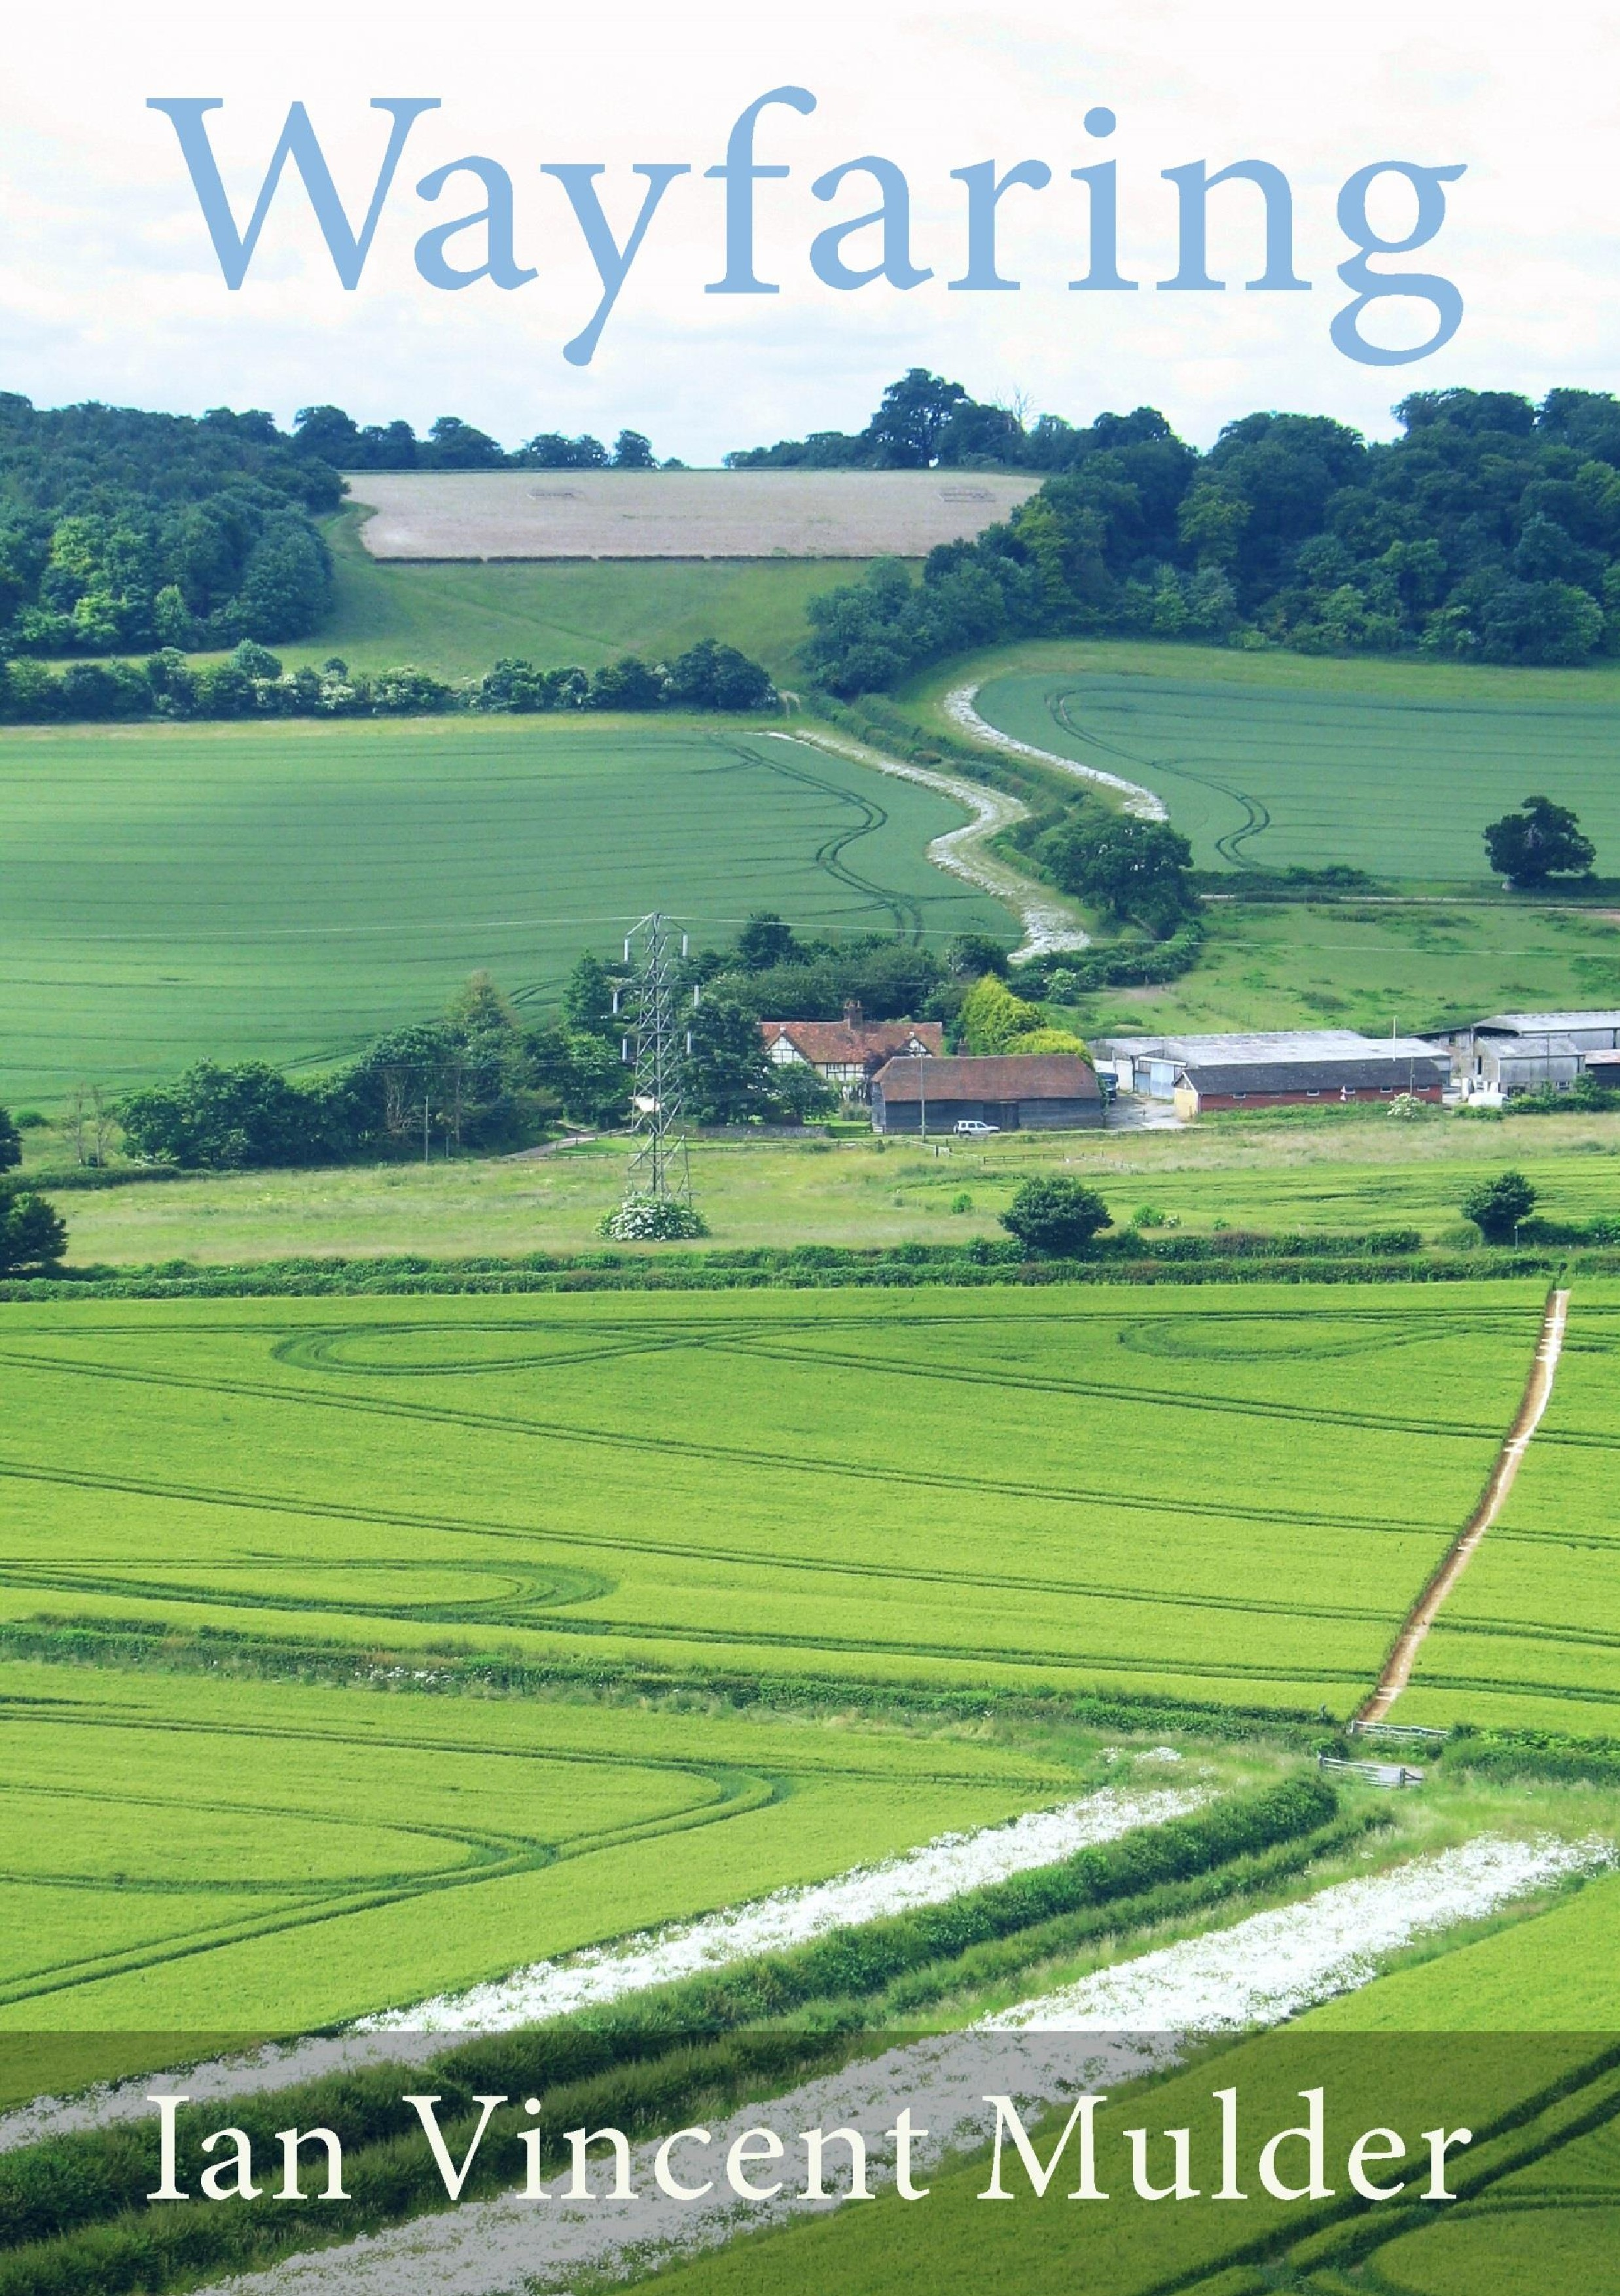

Wayfaring

Ian Vincent Mulder

This preview edition is licensed under the Creative Commons AttributionNonCommercial-No-Derivatives 4.0 International Licence. To view a copy of this licence, visit http://creative
commons.org/licenses/by-nc-nd/4.0/

All essays in this book are derived from http://perpetual-lab.blogspot.com “A Wayfarer’s Notes”, where you may contact the author by email & obtain news of print & e-book versions.

For every thing that lives is Holy.

William Blake
(The Marriage of Heaven & Hell)

Contents
1. August 1
2. going it alone 3
3. unto the hills 6
4. on a bus ride 8
5. beginnings 9
6. new morning 14
7. fragile 15
8. outsider 16
9. animal 18
10. bleak midwinter 19
11. rituals 21
12. prophecies 22
13. covenant of water 23
14. pedestrian 24
15. Springtime 25
16. Mill Pond 27
17. “ce que vouldras” 29
18. impulse 31
19. dishonour 33
20. greeting strangers 35
21. thankful 39
22. Basho 41
23. archaeologist 42
24. unto the hills 2 45
25. space & time 48
26. touching Eternity 53
27. on high 58
28. trail to Marlow 62
29. pilgrimage 65
30. not trying too hard 67
31. Spring be my Muse 70
32. whithersoever 73

August
I’ve been wondering what spirituality means. I don’t see how I can possibly know; which is odd considering how I spent the last thirty years. Religion has become opaque to me, for I feel myself to be an animal: maybe a puppy not properly trained. I have only to leave the confines of Indoors to wag my tail in ecstasy. Finding myself tailless, I must let these words do proxy for wagging.
It’s August. There was rain but now the sun has warmed every surface. Fences are steaming, undergrowth exhales heady aromas. Lazily, I don’t want to go anywhere or do anything in particular. It’s enough to just be, soaking up the surroundings, whatever they are, exactly as people do on a beach. As I say this, memory presents various sense-inputs from adolescence: decaying seaweed, icecream, sun-tan oil on young women and muscly young men, sweat, cigarettes, decaying crustaceans, hot dogs, dog-dirt, damp sand. That’s just the smells. Add a backdrop of glittering ocean in the setting sun, mournful cries of seagulls wheeling overhead. I hear the constant ebb and flow of waves on shingle, sounding like the very lungs of creation. Wafted on the breeze are distant children’s cries, sharp, ecstatic. If you are prone to synaesthesia, they’ll remind you of shards of coloured glass endlessly shifting in a kaleidoscope, never the same, never different.
What I’ve touched and sniffed is more real than topics of the day chewed over on the radio, the tedium of committing to work, deadlines, meetings. So I’m drawn to spending my Saturday on an actual beach. But then I realize that it would entail more of the same: more planning, traffic queues, compromise and constraints. Let me go where all is wild and everything is possible, in flights of fancy and remembrance. Above all, let me walk and feel the earth under my feet, with the force of gravity making sure I don’t float away.
———
In daily respite from office craziness, I spend my lunch-hours exploring the neighbourhood. Eight months I’ve been working here and still not gone back to the place where the crystal therapist lives. Someone had recommended her for my illness, given that all else had failed over the years. I could say that those visits had no lasting effect; or I could point out that three years later I was miraculously cured in a moment. Cause and effect is notoriously hard to prove, so who knows? She may have set something in train—along with everything else. Her core therapy was to select crystals and line them up on my chakras. I’d lie on a massage table and she’d balance these semi-precious stones on my abdomen: all very pretty and harmless. But I best remember a meditation she gave me to do at home. Draw up energy through your feet from the earth as if they are roots, she said; let it disperse through your branches and twigs, that is, your arms and fingers. Feel your leaves grow; provide roosting for birds; absorb the sun’s rays and atmospheric carbon dioxide; release oxygen. Remember you don’t have to do anything to make these things happen. Nature takes its course, that’s all it does. This too is your nature. Don’t stand in its way. I only did the exercise consciously a few times, but that’s the whole point, I think. “You don’t have to do anything.”
Here’s her house, not far from where I’m currently working. Now I don’t know why I came. Perhaps it happened naturally. Knock on the door, say “Here I am, came to say thank you for having possibly helped”? No, I could send my thanks in an email. I only came as an excuse to walk the earth, and make this journey in memory at the same time.
There is nothing grand about the houses in her suburb. They are merely immaculate: complete, as if their owners have finally arrived, and have nothing left to do in life but stay that way, like swimmers treading water. I’d find it stifling to live there. One might as well settle into a silk-lined coffin without waiting to die first. I’ve always felt this way about bourgeois comforts. My life is perennially half-finished, with scaffold-poles still in place, piles of bricks and sand alongside.
Like a gypsy or an Aborigine, I feel imprisoned within four walls. Outdoors, I’m a player, a participant in—all this, regardless of what this is. I pass a currant-bush and tear off a couple of leaves, to crush them and sniff their distinctive aroma. I can imagine nothing better than to lose myself in this moment. In such ecstasy, I need nothing and no one, not even a house to live in. I could be a tramp, a choiceless beggar. Every situation has its special charms. People have hearts of gold, some anyway, and the others can’t help being what they are, or perhaps they can, but in any case I can’t help them being what they are. I feel like someone in a lucid dream, able to float anywhere and do what I want.
Now I am at the Great Hollands Shopping Centre, a modest square of grass with its modest local shops, a pub and a National Health clinic. This is where nobodies, elderly and unemployed descend from the local bus to potter around for a while. Here the graffiti give the main hope of artistic creativity, and dropped litter is a pathetic form of defiance. Is this the world as it is, or merely its dream of itself? In either case I’m part of it. I shall not stay aloof, for who am I? a mere wayfarer passing through, striding over the earth’s crust like the giants, or indeed the dwarves, of old; like everybody else.
At the back of the Shopping Centre, at the far corner of my picture below, there’s a pervasive aroma of smoked red-pork: star anise, cassia, citrus rind, ginger. Like an orang-utan sniffing a distant durian-tree, I search my memory for its source—the Chinese stalls in Kota Kinabalu and Kuala Lumpur. Durian and red-pork, both.
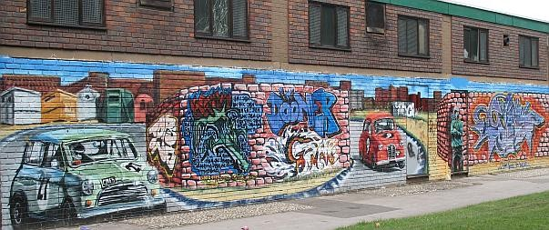
I periodically renew my resolve to write a coherent memoir, but get distracted by the beguiling flavours of the moment. Nothing is more important, nothing touches me more. And everything arrives mixed with everything else. Needless to say, I acknowledge with thanks the blessedness of this hour. Blessed art thou amongst hours!

going it alone
What makes us the way we are? What sets us off on our own unique path? Heedless of a fine drizzle, I set out on foot to West Vale, pondering these questions. In the rhythm of walking, imagination comes alive, presenting my whole life as a connected whole. I find myself composing a memoir on the theme of travelling alone.
I spent my early childhood in Bassendean, a suburb by the Swan River in Perth, Australia. I recall that we lived in a cheap lodging house amongst easygoing young women who giggled a lot and kept an eye on me. Apart from their gentlemen visitors, there were no men on the scene. Soon after I learned to walk, my mother left me in a playpen on the veranda. She was shocked on her return to find her toddler gone: not just me but the playpen too. Instant panic, till a neighbour reported me using it as a walking-frame, and making for the unfenced riverbank as fast as my little legs would go.
When the war ended, my newly-widowed mother yearned to return to England. I adored the happy-go-lucky life of Bassendean, but for her it was a sorry makeshift. She felt herself a cut above: her family coat of arms was in Burke’s Landed Gentry. Soon after my fourth birthday, we set sail on the mv Rangitata bound for Tilbury. As the ropes were cast off at Fremantle, I stood with other passengers on deck waving to loved ones left behind on the quay. Mother never told me that my real father was amongst those seeing us off, and certainly took care not to introduce him to me. I didn’t know what a father was.
On board I escaped from her at every opportunity, exploring the ship from top to bottom and bow to stern, wriggling unimpeded through doorways and up companion-ladders. The crew would chase me from their deck, but I got kindness from six hundred mother-substitutes. The ship was full of war brides emigrating to join their fiancés. After six weeks on board, I remembered no other life; till it came to an abrupt end with our arrival at Tilbury.
Returning to an England of bombsites and scarcity proved a shock to my mother. Even her parents’ house had been bombed. She’d spent the Thirties in Singapore as a dancing teacher, with cooks and maids and chauffeurs and Chinese millionaire clients and a tall dark handsome husband. Possessions, husband, way of life were all wiped out by the Japanese invasion. She escaped with her life, and now her little bastard from Bassendean.
After the winter of ’47, with deep snow and no heating in my grandparents’ half-wrecked house, she had the bright idea of finding a wealthy husband in Switzerland. I’ve no idea how she thought of that, or whether she would have minded if she’d met a Nazi on the run from the Nuremberg trials. She hated only the Japs. On the way, I was dropped off to lodge with my “aunt” in Holland. Auntie Non had two infants of her own, so I as cuckoo in the nest was shut out of the house on fine days to fend for myself, hours at a time. I explored copses, browsed bilberries. I saw blood and feathers left by foxes after raids on chicken runs; sacks of grain being pulleyed up to tall storehouses at the wharves. I found a field strewn with tiny pieces of metal. We lived in a village near Arnhem. It wasn’t till I watched A Bridge Too Far, not long ago, that I understood what might have gone on in that field, three years after the events so accurately portrayed in the movie.
I was sent to school on my own each day with a little tin of jam sandwiches for lunch. I dodged the big barking dogs and lingered at the smithy, where the furnace roared. I winced when the smith burned in a new shoe on the horse’s hoof and secured it with nails. My Dutch became fluent as my previous lives faded like dreams. Lives? I was still five years old.
Months later, my mother turned up for our trip back to England, after the failure of her Swiss adventure. My life in Holland, with my ersatz family of aunt, uncle, grandparents and cousins, had to be left behind, along with school and the Dutch language. Back to my English grandparents and part-time mother. When I opened my mouth to speak English, Dutch came out. Fortunately, Granny had taught me to read before this period abroad, using a famous Victorian primer, Reading Without Tears. Now my “aunt” regularly mailed books in Dutch—a continuation of the series I’d had at school. Neither of us knew she was no relation. The books got more advanced, but my ability to read them diminished. At Christmas, she sent me a sumptuous story-book, meant for an older child. I recall its exotic illustrations in water-colour. Try as I might I could not fathom the text, only that it seemed to be set in the Dutch East Indies, with jungly moonlit scenes and a sense of unfathomable mystery.
Now my mother was bored to be back in the parental home from which she had escaped at 21, inspired by Doris Holdsworth, her own dancing-teacher. She started seeing a gentleman in the next town, a bachelor twenty years her senior. One day she ’phoned my grandparents from his house to suggest they put me on a bus to come and meet him. This sudden whim seems odd by today’s standards, or perhaps any standards. I can only speculate that her afternoon trysts had yielded a proposal of marriage, and so I would have to be displayed. I was told to ask the driver to let me off at West Hill. There are West Hills in both towns and I got off at the earlier wrong one. I wandered around feeling foolish until my grandfather found me hours later, by dint of combing the area in his car.
Soon after my sixth birthday I acquired a stepfather, followed not long after by a sister. It might have been the start of normal family life, but I was sent to a boarding school seven miles away. At half-terms I had to go home by bus. My stepfather’s car was garaged somewhere and not used for short journeys . Once I arrived to find no one at home—they had forgotten I was coming.
My happiest school memory was one half-term when I was ten. I was told not to come home. I didn’t know it yet, but my mother had finally walked out on the stepfather and gone back to her parents. A fellow-pupil, I believe his name was Cooksey, lent me his bicycle for the weekend. I had never ridden a bike, and there was no one around to help, but I spent every moment of those two days on a stony track through the woods. Bruised, bramble-scratched and nettle-stung, I fell into bed when the light had drained from the sky. My dreams were all of bicycle-riding.
At dawn I leapt up and back into the saddle, still sore from the day before. Astonished, I found that I could ride without falling off, as if I’d practised while asleep. Boy and bicycle, joy and triumph, all alone in the woods.
Thus I became a wayfarer.

unto the hills
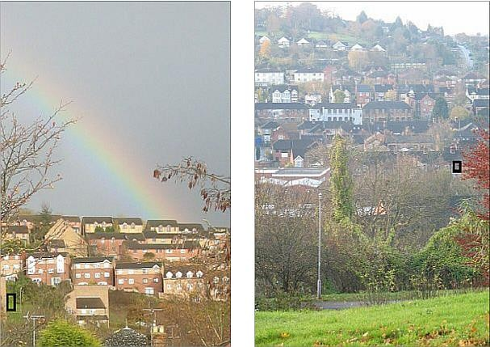
I went up the hill, the one at left with the rainbow. That’s how it looks it from my study window, which I’ve outlined in black in the right-hand picture; which in turn was photographed from the spot outlined in black on the left. This town is full of sight-lines, with varying perspectives from valley or hillside. If you can see from here to there, thee must be a place where you can also see from there to here. It’s a town where I can always “ lift up mine eyes unto the hills,” as in Psalm 121.
I trudged up in the morning drizzle, wandering through the suburban maze, while people drove off to work. Past the crowded houses you see in the left-hand photo, it thins out and becomes a level plateau, with residences standing detached in their own grounds. I heard some voices, loud but some distance away. They sounded like workmen cheerfully chattering and clattering on a building site. But as I passed I heard these words through the hedge: “What allegiance do I have to my brother, and my father, and my father’s brother? Only one thing. To work. And there ain’t any work around at the moment.” Then there was a gap in the hedge and I saw (without gawping or slackening my pace) that the speaker was a young man pacing back and forth on a scaffold platform, beside a half-built brick wall. He was waving his arms in agitation. Two or three men on other parts of the site paused from their work and stared perplexed. Were they the brother, father and uncle in question? It was a Hamlet moment, or even a Jacob and Esau moment: but it wasn’t enacted for the entertainment of eavesdroppers: I had to move on. From this one scrap of rhetoric one could write a whole play, a topical drama, say, to illustrate the effect on a family of the credit crisis; or of existential anguish generally.
Up to that moment, I’d been mentally composing a letter, wrestling to understand a family dilemma of my own. My thoughts almost echoed what I’d just heard, for they went like this: “My late mother and her sister, my own self, my four children, my three grandchildren: we seem to be linked by a ‘rebel gene’. We flout the conventions—I admit it in sorrow, not pride. Now I’ve become the reluctant patriarch. It disturbs me to see what is happening. My own past caprices entrain a legacy of travail and now my grandchildren are affected. I don’t want to see them needlessly handicapped by rebellious ideology, pointless contrariness. Perhaps it’s me, perhaps I ought to see it differently, and accept that others must proceed by trial and error, just as I did.
I want to stand on a scaffold too, and rant like that young man: “What allegiance do I have to you? Only one thing: to give your children what they need—a grandfather.” Perhaps I’m King Lear, victim of his own foolishness. I possess a film version on DVD, with Paul Scofield in the title role. I saw him playing Lear on the stage at Stratford-on-Avon in 1962, a memorable performance, but I find it too harrowing these days. I’ve been reading Huckleberry Finn lately too. Am I in some way like Huck’s Pap, trying to force my ideas on my eldest son? Ideas opposite to that disgraceful drunk’s, as it happens, but that’s no excuse.
Possibly I read too much into coincidence. Hamlet, Lear, Huck Finn’s father, the ranting man on the building site—why should I see myself in them? Yet perhaps this world is a mosaic of mirrors, that I’m only beginning to recognize. Mostly we see nothing but a chaos of images. Then, when we see a pattern, we call it truth, discarding the rest. What makes no sense in our movie is mere celluloid that we let fall to the cutting-room floor. Writing is the same kind of thing. This is my movie.
My children copy the things I’ve long renounced, ignoring what I say today. My children copy the things I’ve long renounced, ignoring what I say today. I wish I had a politician’s honeyed tongue to set things right, or even a shaman’s magic to alter the past. All those years, I swam against the tide to no good purpose. Now I wish they would not follow in my abjured footsteps. “You’ll just have to trust me,” says my son. He’s right, and I shall also take comfort from the Psalm:
The LORD shall preserve thy going out and thy coming in from this time forth, and even for evermore.

on a bus ride
Perhaps I’ve reached an age of wisdom, ready to rejoice with the fortunate and be one with the downtrodden: to see someone beautiful and young who is making the most of what he or she has, without envy. At university, I’d have done better to appreciate those around me—and my own self, most of all. Anyway, here I am back present in the world, seeing the whole thing in microcosm. I needed to get out of the house since I seem to stagnate indoors. I don’t want to be embalmed while still alive. I wouldn’t want to spend my last hours in a hospital. Even the walls of my own home would be a kind of coffin. Put my ragged remnants in a wheelchair and push me over a cliff. I’ll shout “Wheee!” like a child on a fairground ride. Thus will I depart in style. Leave me under a tree with nothing to eat or drink; let my flesh and bones dissolve into to the landscape. Park me on a lonely beach, let me die within earshot of the plaintive waves.
“All truly great thoughts are conceived while walking,” says Nietzsche, quoted by Beth, whose blog is called “Living a Quotable Life”. Walking in the rain near home has lately dampened my sense of wonder. No act of conception, no great thoughts gestated. That’s why I’m here scribbling in a black book on a bus, just I used to do, commuting to the City on the Tube. On the back seats behind me, African girls are chattering and to me it’s pretty like birdsong. The drone of the diesel, the rhythm of starting and stopping—these remind me of every bus I rode in childhood.
And now in the birdsong of voices I hear a single English phrase: “a nice boy”. Later I discover that in Shona it would be “mukomana waka naka”, so I’m not surprised that the shorter version was used. But it catches me unawares, for I feel myself to be still that nice boy, riding a bus more than fifty years. Only a clairvoyant would look at me now and see that boy, or perhaps a crystal therapist, if you crossed her palm with silver. Even my yearnings have not changed, except for the direction of travel. Then I saw my treasure as something buried, waiting to be mined from the ore of the future. Now I pan for gold in accumulated silt of the past, guided by scent, sight or sound of the present moment. Be here now, said Baba Ram Dass, or was it a title chosen by his publisher? Sometimes in a droplet of “now” I find spacious worlds.
The bus windows are steamed-up on the inside, rainy on the out, so I can’t see where we are going. I don’t know when to ring the bell to get off. Like a shy child, I don’t want to ask, preferring to hope someone else will ring at the appropriate time. I’m in a timeless time machine, peering through the glass, wondering where is here and what is now; on a journey of retrospect, where the past means more today than it did at the time.

beginnings
My head says that the perfect wayfaring expedition is to follow an ancient trail through the hills, where the eye can roam to horizons beyond where the feet can tread: a Himalaya or Grand Canyon of the soul.
My feet know better. The other day, I set out on a banal errand, accompanying my beloved to town on a Saturday morning to the Post Office and thence to the market where she would buy yam, green banana and other West Indian staples. She usually makes these trips alone because I prefer the long strides of a hunter, and don’t like to hang around shops. So when I saw the queue at the Post Office, I left her there, promising to seek extra memory for her computer, and an LED light on a flexible stalk that clips on to the bedpost, for reading and writing without disturbing her sleep in the hours of stillness. Neither item was available in the High Street, so I hied me to a retail park along the valley.
This was when my feet expressed their gladness, filled with vigour, as when a dog sees its master unhook the leash and put on his walking boots. Mine were on already, as an unconscious part of me had planned to break free as we set out from home. Retail parks are designed to be reached by car, that’s their whole point. But I know a footpath beside the secret river that winds behind industrial premises, the sewage works and the disused railway line. I call it my Valley Path.
As I traversed The Rye, a grassy park mainly given over to playing-fields, ideas started fluttering around my head like moths towards lamplight, drawn by my empty and receptive head. The surroundings seemed to offer themselves as modelling-clay responsive to my passing through. Together, we were eager for new beginnings. What struck me was not the beauty of anything in particular but a perfection inherent in the moment: or perhaps an embrace between subject and object, man and scene.
Following the river-bank, I saw things clearly as if in simple diagrams: for example, that what stops us learning is the part of us which says “I already know about this”, and scuppers our curiosity. So if the phrase “unconscious mind” crops up, I say, “Oh yes, I know about that: Freud and Jung stuff.” As if I can’t see things for myself, but have to learn them through the eyes and words of others. Or perhaps I protect myself from anything new, or anything that might be boring. Perhaps I say to myself “Heaven knows, there are too many ideas already. They need to be silenced, to give us some peace.” But I could learn, by letting myself merely observe, merely listen to the miracle already taking place: not without, not within, but the interaction between the two. My wayfaring is not to enjoy nature, even though my head thinks it is—that tree, this leaf, yonder panorama—but to put the universe back together, connect time and space through the dewdrop-lens of this moment. And in some way to reconcile my new seeing with things I was taught in school, such as history, evolution, The Bible Designed to be Read as Literature, the names of wild-flowers, how to use carpentry tools.
I see in myself that oneness, that non-duality, symbolized by the Centaur. He is a creature half man, half horse. This physique condemns him to live in the forest, untamed, for he can never dwell in a house. So he is confined to the margins, liminal, ambiguous, on the edge of society. Much of what he was taught, much of civilization, makes no sense to him. For we are taught to be riders, exercising our minds, i.e. wills, on the dumb animal, the mechanistic structure that is our human body. So I learned to be a rider like everyone else but it was alienating. Through books and abstractions I tried to gain understanding. But that very process was one of repression, ignoring deeper impulses. I was not just a thinking creature made in the likeness of God. I was also an animal. In the civilized world of ideas, thoughts are imposed on you, at second hand. You are at constant risk of losing touch with your own ability to see things—within you and around you—as they actually present themselves. When that repression is lifted, ideas spring forth unbidden from somewhere unknown, to become truly known.
I suspect there are innumerable discoveries to make but we have to be like a child in front of them, hungry to learn, not weighed down with the staleness of the preconceived. Darwin was like that. BBC radio is celebrating his centenary, and also as it happens 800 years of Cambridge University, which started as a group of students fired by eagerness to wrest secrets—theological or scientific— from the bounteous æthers.
It’s always worth going back to the source: to the moment when something began. Where did man begin? In Africa, they say. I have never set foot on the continent, but my body, or if you will, my unconscious mind, dreams of it constantly, for though my skin be white, my ancestors come from a region around Kenya, like yours. The closest I got to Africa was in 1946 when my ship anchored at Port Said on its journey through the Suez Canal. Passengers could get off to buy souvenirs and feel dry land under their feet after weeks sailing from Fremantle, but I stayed with my mother, looking over the rail at naked boys diving for pennies. I was astonished. Some of them were scarce older than me—I was 4—yet there they were, in Paradise, unconstrained by mothers. Mine gave me a couple of coins to throw and each time the boy caught it before it sank to the bottom, and bobbed up like a cork grinning and holding it in high triumph.
I’m trying to convey some of what went through my head as I walked to the retail park along the valley floor beside the humble river. It was a quiet sense of exaltation. I felt privileged to participate in the world’s discovery, not to be celebrated as a discoverer, but merely for the joy of looking and revealing ways of looking. I’m not talking about a particular discovery, a new idea that runs through academia like a benign infection, but a kind of seeing. For anyone can do it, or so I believe without tangible evidence. There is a special kind of learning: to know how to tune to something you never knew was there. Once you have seen it, you know you can see it again.
The retail park has been built on the site of an old paper mill. Originally it used river-water to soak wood-pulp from the trees in these surrounding hills, and water-power to drive the machinery. I’m glad I found this route to get there. The trail, partly an old railway line, has not yet been razed by bulldozers, but they’re going to build alongside. I want to write a piece about it, entitled “Enjoy while you can!” The best things to celebrate and immortalize are those which cannot last. Never mind the eternal and infinite, those ultimate abstractions, and the so-called Almighty. They can look after themselves.
All this I see will disappear, though I’m sure that miracles will never cease, and Gaia, this intelligent Earth, will shrug off the worst we can do, and us as well if necessary. And as for this unique combination of body and ever-sharpened intelligence, with a consciousness that allows joy: you and I are like the original cast and crew of a film. Once they have dispersed, nothing is left but a record on celluloid or digital media. So be it.
As I think these thoughts, I’m following the old railway line. No rails, no sleepers any more: just raised earthworks and a ditch.
It’s not my aim to leave a legacy of writings, or to change the world, or even to populate the world with human offspring who may do it on my behalf. It’s enough to go on being excited about life.
Here in the woods near the old railway line is a sewage works, at the town’s lowest point. Its input (rainfall collected from street-drains) arrives in a large iron pipe. Its output is pumped into the river, enlarging it downstream. You hear the sound of a man-made waterfall and the constant low hum of pumps. And here if not before, I see that my heightened feeling, my overflow of joy can’t be explained by a mere “love of nature”. I stand in a triangular hollow, bounded by the river, the diagonal path and the old railway line together enclosing a shallow pond over which the big pipe and a smaller one are supported by brick columns. The pond’s surface is disturbed in more than one place by a bubbling spring: you can see one in the middle of the photo under the pipes. I must be an engineer at heart, for all this fascinates me. The more so because I’ve been here before. It has become a place of anticipation, of pilgrimage. There was eagerness in my feet when I contemplated coming here. The unconscious mind makes itself known, tells me its content. The horse knows much that the rider need not concern himself about.
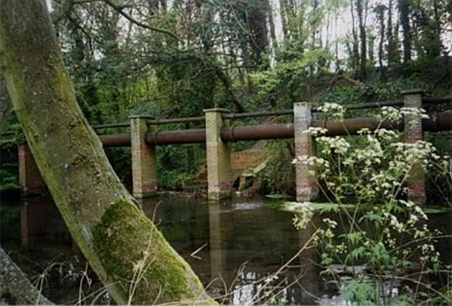
I see that in a child’s world, a mammal’s world, a true human world, there is an endless fascination in repetition: the same only different. Music: rhythm, melody. We seek the new, we return to the familiar. I don’t seek to understand or explain this. I merely observe and report.
There’s nothing grand about this river. It runs behind industrial premises, some being derelict. It’s twelve-foot wide at the maximum. The path is muddy. But it has the power to evoke parts of my past life. Good parts. Parts I never understood at the time. I don’t mean just my life, but the entire world I observed. Things that were happening in the world, that I was born into. I give awed thanks for that life.
Eventually the footpath debouches into the retail park, for which too I give thanks, I cannot explain why. It’s ugly enough. PC World doesn’t have the computer memory I came for, but Argos does have the clip-on flexible-stalk LED reading-light, which works just as wished and imagined.
On the bus home there are two boys in front of me. The larger one is a pink-faced flaxen-haired lump of a lad. The other is a dark-haired boy with some audio device feeding sound to his ears through wires. He looks more intelligent or from a more privileged family than the pink-face, who holds forth loudly whilst he remains quiet. I don’t tune in to their conversation at first, but the larger boy speaks of a third person, compassionately recounting his shortcomings and peculiarities. The smaller boy listens rapt, as do I. From his seat, he presses the bell-push to request the next stop. The pink-face says “Oh, is that what you’re doing, seeing how late you can leave it to press the bell?” The smaller one gets up to go. “And you’re seeing how late you can get up to go?” I wonder if the shapeless pink-faced boy is intentionally charming the other, by making the trivial events in life into something of note, something to remember. It works on me; and I aspire to something similar.

new morning
In the last few days something happened to me. It felt as though “I have found my power”. In 1972 I read some shortened English version of Valmiki’s Ramayana, which if my memory is not distorted began with some yogis competing for “powers” (called siddhis) through fierce meditation, zealous fasting and strenuous renunciation. Looking back, I think its very exaggeration must have had a satirical purpose, but I was too earnest to notice that at the time.
———
I went to a conference of therapists last weekend, designed to educate us in the latest techniques, and give us renewed enthusiasm. For me it did the opposite, reinforced the feeling that none of this was for me. “So what are you now?” asked one of them. Rebelling against the scripts we’d been taught, I found words in my head from I know not where, and replied “A world-child” without troubling as to what it meant. Perhaps it means I’m orphaned no longer, having found my long-lost mother, the earth.
———
What else shall I renounce? Being middle-class, for a start, not that I’ve ever admitted to it, not even to knowing what it means. In fantasy I’ve been a member of some invisible aristocracy of poet-philosophers, some Dead Poets’ Society. Descending from Parnassus, let me start by belonging to this neighbourhood. They call it The Pastures. The houses are fairly new, clinging to a hillside like those in Santorini or Amalfi (which I’ve only visited in imagination), except that they are mostly ill-kempt social housing, quite recently built but mellowed, if that is the right word, by litter, splintered fences, graffiti, bottles, cans, broken washing machines dumped in unkempt corners. But if there was conscious pride and effort, it could shine. The ingredients are there. It faces south to catch any sun: there are paths, steps, creepers, shrubs, retaining walls begging for adornment, cats sprawling in the afternoon sun. A forlorn doll had been left on some steps. Children would grow up here, probably want to go far away, but they’d have memories. I hear a parent shamelessly yelling at her child, who was struggling to move a rubbish bin taller than herself. All human life is in a neighbourhood, both comedy and pathos.
Sentimentally, I tell myself I’d be happy live here, instead of the two rooms I currently rent not far away. I would blend in, rise to the noble status of “working class”. As if to establish the point, I stop to talk with a man washing his car. We almost swap our life-stories; at any rate we recognised we have much in common. He shows me round the inside of his place, a habit he’s got into because he’s put it up for sale, and pointed out various other houses for sale nearby. It seems like an omen that I shall find a new identity.
I’ve renounced being a full-time idler, professional cloud-gazer, pilgrim of windswept paths. I expect to be commuting into a regular job soon, like workers everywhere. It’s a step forward into some new phase, some new connection, as yet unknown.

fragile
The eastern sky glowed golden yesterday morning, over the chimney pots and the tower of All Saints’ Parish Church. I saw the outline of a hundred wheeling birds, swallows I think, gathering for their departure to North Africa. Later as I went walking, some half-denuded shrubs were full of birds chirping and hopping excitedly from branch to branch. I don’t know what species, but there was a white flash on their wings. Then as I crossed a stubble-field, moving out from the hill’s shadow to the sunny part, I heard more birds, and they were excited too. On this chill day, the last in November, when I’d have found gloves welcome, a mass migration South was being planned; or else these flocks had just arrived from further North.
———
Driving K to work earlier, I’d taken a back road to avoid traffic, but this was busy too and we proceeded in stops and starts. I’d been aware of a motorcyclist behind me for a couple of miles. He was cautious and patient. At last there was nothing coming the other way, and when we halted behind a stationary queue, he carefully overtook us. A few seconds later, at exactly the wrong moment, a car came out from a side road, just as cautiously as the motorcyclist, because he could not see till he had stuck his nose out. The motorcyclist swerved to avoid collision and fell off, rolling on his back with legs in the air. He got up a little shaky and immediately tried to push his bike to the edge of the road. No one helped. I wanted to get out and at least offer friendly words in his moment of shock, humiliation and pain. Our line moved forward and I wanted to park up the side road so as to see what we could do, but he’d walked up there himself, and now he was talking to a sympathetic woman pedestrian. He was a complete stranger but somehow I felt moved. There he was, some mother’s son. Perhaps she was a widow and he an only child and she told him so often to be careful, her voice became lodged inside him, constantly nagging. At any rate, it looked as though his falling-off was entirely due to nervous caution.
———
Every mother has to let go of the son she has carried in her body and then suckled: let him go to possible danger or death.
And I thought also about the plight of migrating birds, when they encounter hostile weather conditions and get blown off course. Nature gives them the instinct to optimize the balance between weight and fuel (food-energy) in preparation for these long flights. Despite such efforts, a storm can defeat them.
And I hear on the news about a mother whose son was killed in the Twin
Towers on 9/11. She met up with Aicha el-Wafi, the mother of Zacarias Moussaoui, who was convicted for his part in the attack. They united in grief and helplessness, offered one another friendship and support.
———
What is common to these three things: The fallen motorcyclist, the mothers brought together by disaster, the migrating birds flown off course? They fill my morning with a sense of fragility and loss, concocted from imagination.

outsider
I rejoice in the sense of my own sure-footedness and the comfort of a buttoned cardigan, on this chilly August day, walking across a stubble-field in a slow insistent drizzle. My path takes me behind a row of sturdy houses. Their backyards look untidy from the rear, with canvas chairs left outside to get wet, children’s toys left strewn for another day.
This fresh-cut stubble is more golden than the dull ochre of uncut barley. It gleams metallic, even on a damp overcast day. To be “sound in wind and limb” gives me an overflowing sense of gratitude; to feel in my prime, like a young man. I wander with no dog as companion, just this voice-recorder, to share immediate impressions. Since a stubble-field has already been harvested, you are no longer obliged to keep to the footpath. Wandering unimpeded, I go to the top of the ridge for a long-range view on all sides. Here I catch a sharp wind. Amongst other detritus, I find an unopened bag of potato crisps. I open and eat. Is it angel-sent, Manna from heaven? Ugh! I think not, but I finish it anyway, so that I can screw up the empty bag and put in my pocket, rather than drop litter in the clean countryside, even though it was already litter when I found it. Compared to the blessing of home-cooked food each day, such factoryfare seems as ashes in my mouth.
From this place, Gore Hill, I look down on roof-tops and survey the world of work. Over there is a car park, whose attendant, in a yellow reflective vest, checks the authorisations of each arrival. Fortunately, as a pedestrian, I can go there without being stopped. I shall wander, lonely as a cloud, through concrete mazes of the built world. I am uplifted, cleansed by the wind. My spirit swells, as if to express “This is my home. It welcomes me.” What more could one ask?
It’s true that I’ve only been able to walk like this for the last year. Before this, a mysterious illness made it impossible, except in imagination. Even in dreams, I’d roam like this amongst the hills, anxious that I’d run out of energy and be stranded.
Now is the time of thanking God, an invented god if necessary, just to have someone to thank. I descend the hill to Whielden Street, under the Cornes Bridge, where the bypass goes overhead. Pigeon families roost here. Dried guano is crunchy underfoot, and the sound of vehicles overhead echoes dully. Turn left and I’m at the Hospital, passing first the Haleacre Unit, where brisk nurses guard the insane. I look down a slope to their exercise yard, protected by a high wire fence, like a POW camp. A man stands, reading his newspaper and smoking. Two other patients are engaged in deep conversation. I’m sure I look madder than they, with my cardigan bedewed in drizzle, a floppy canvas hat low over my eyes.
I reach the car park attendant and greet him politely in passing, as walkers do on country footpaths. He’s startled as if caught out, stammers a reply: “Good morning, Sir.” It’s the senior staff car park, where pecking order rules. Poor man. He must think I’m an off-duty Professor of Psychiatry whose face he has unaccountably forgotten.
I stride towards the interesting building I’d spotted from the hill. Its plate says “Day Nursery”, and it’s a dead-end, even for pedestrians. A couple of women eye me suspiciously, as if I were an ogre seeking infant flesh for breakfast. I look back at the golden hill of barley stubble, where I was standing just a few minutes before. Gazing from a distance or being there, which is better? I’ve been on both sides now.

animal
To be a specimen of homo sapiens sapiens is to be an animal. There was a creation myth, in Genesis, where God said, “Let us make man in our image, after our likeness: and let them have dominion over the fish of the sea …”. Darwin threw down his challenge to think differently, but that was a mere 150 years ago, in my great-grandfather’s lifetime. I embrace Darwin, but I won’t be hasty in throwing out the older ways, which fashioned the civilization I find myself in. I get my notions of truth from that which resonates in my soul. I’ve always argued with Christianity, never yet with Darwin. To see myself as animal has coincided with a liberation in my soul.
Brooding on such topics, I returned this morning to Gore Hill, where the stubble still stands but another field is freshly ploughed, as if to herald Autumn. Pausing at a secluded hawthorn hedge to answer a call of nature, as one says, I heard a rustling and saw on the ground a young wren, unable to fly, its breast throbbing in panic. I could do nothing to help my fellow-creature, only move out of its way. I reflect that an ancient hunter-gatherer would have had the same sense of respect, since it wasn’t worth eating. Later I saw the remains of a fox, just skeleton and a bit of russet fur; then a bedraggled field-mouse, belly-up, its front paws clenched. There were close encounters with several fleeing rabbits. I paused for two minutes in front of a beautifully striped snail. When its eyestalks and feelers were fully extended, and the sun lit up its miniature scene, I asked it to “smile please” and clicked. My camera’s batteries chose this moment to go flat, otherwise I could have shown you a trophy portrait of our distant cousin.
The last time I looked down from this airy hill towards Amersham Old Town, laid out in the folds of its valley like Camelot, it made me feel connected to something beyond my own tribe. High places lift the soul. I think of Moses, when he went up the mountain and came down with the Ten Commandments; Nietzsche’s Zarathustra; Gibran’s Prophet. They went up into solitude, received a message, came back down to rejoin the people.
Diverging from my previous route, I found a beanfield. Its plants were withered, the remaining pods blackened. I looked inside: they were just like Heinz beans. I couldn’t imagine Heinz buying these from a local farmer. Only later did I work out that they must be specially planted as winter provender for pheasants, encouraging prolific breeding for the next shooting season.
Again I found myself saying, “I am an animal”, as if I had been reborn as a physical being aware of my body, instincts and kinship with fellow-creatures. It makes me wonder what I was before.

bleak midwinter
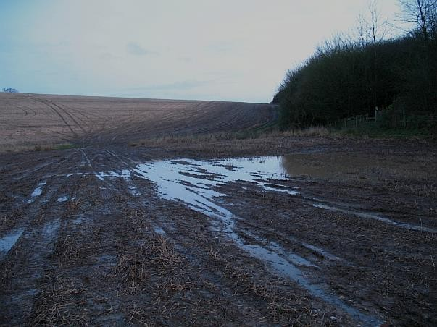
Of all the world’s festivals, surely Christmas is the most renowned; full of stories, contrasts and potent symbols.
Like many, I dread the tawdry commercialisation. But now having spent an entire year celebrating the daily advance and decline of Nature’s rhythms in the hills, woods and fields, in all weathers, I see it differently.
I ventured out on a wet windy afternoon, the sun already setting, Winter Solstice nigh. The ground was waterlogged, the fields desolate. This was near Amersham Old Town, which keeps a memorial to its Protestant martyrs burned at the stake in the sixteenth century, for committing the heresy of reading the Bible in their own English tongue.
I thought of the local peasants before that time. They’d rely upon their priest or wandering friar for tales of the Christ-child’s birth in a lowly stable.
They would imagine it vividly, having themselves only firelight or tallow candle to push back a little darkness in long winter nights; grateful for the gift of stars and moon. They would feel kinship with shepherds watching by night, suddenly accosted by an Angel: “Fear not: for behold, I bring you good tidings of great joy . . .”; visualise themselves cap in hand waiting to look in a mean shed meant for cattle and goats, whose manger cradled a new-born baby. These would be country folk fending off frostbite, gathering what winter fuel they could, legally or otherwise. Who could set his heart against Christmas, coupled with Yule as a time of generosity, forgiveness, jollity, gifts of food and drink from their feudal lords and “betters”?
It is no wonder that our carols and our cards are about antique snowy scenes and Yule logs and olde England and the evergreen plants so sacred to the Druids as symbols of life: holly, ivy, mistletoe. In olden days in these chilly Northern latitudes, Christmas was full of meaning and comfort.
As I walked the damp darkening fields, I felt glad to discover what Christmas had meant to my ancestors, as if their ghosts were communing with me to tell the tale. I was there with them, they made me welcome. So much so that when I got back from the fields to the main road, I no longer felt at home in the twenty-first century.
Cars roared past at a frightening speed, each one equipped with its own heating and music, each driver hurrying back to a well-lit warm home with plenty of food at all times of the year. They wouldn’t gaze into the embers of a log-fire and repeat the extraordinary stories they’d heard and made real in their own imaginations. Instead, they’d click a button to light up a window of fantasy delights, or real-life horrors somewhere overseas. Everywhere distractions to blot out other ones. I wanted to hold on to my private vision, the honest simplicity of those cold wet fields, those ghosts, their innocent Christian vision, angels, shepherds and three wise men, all made vivid to innocent minds. I want to say we have lost all that forever, that magical vision. We’re trapped in our tawdry false age.
But my brief vision has proved otherwise. Once you’ve tuned in to something like that, you can return to it sometimes, take comfort. And joy.

rituals
Yesterday, I think it must have been the feast of Bakri-Eid (goat-sacrifice), I went out in the morning and saw men and boys in white caps and long loose clothes streaming from every direction towards our local mosque.
By some instinct I was drawn to a solitary pilgrimage, on New Year’s Eve, away from the twinkling Christmas tree and our cosy hearth, into the hills beyond the town. Wind and rain came in wild gusts, driving anyone sane indoors. I set off along muddy paths to the sunflower field, planted in spring but left unharvested for pheasant provender in the autumn. I’ve put up photos of its earlier states:
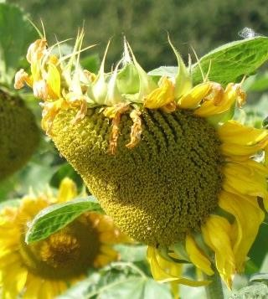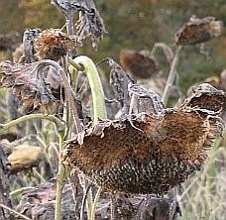

September

early December

New Year’s Eve
Last evening the flower heads were blackened, shrivelled, hanging down in terminal despair: no longer tracking the weak winter sun which in any case had set below the rain-clouds. And now I wonder how it is possible to tell when a plant is dead?

prophecies
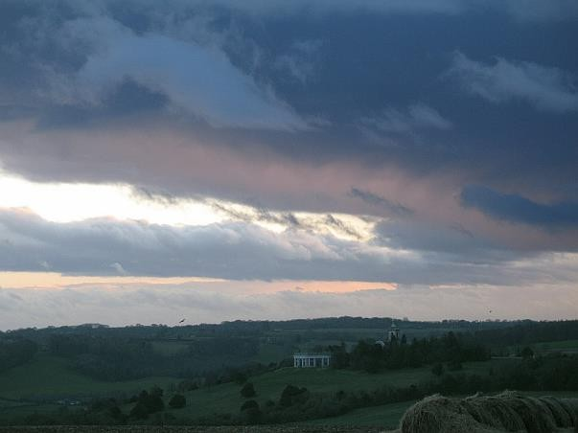
I went to last summer’s sunflower field. It’s been flattened and lightly manured, a pervasive smell of old cow-dung in the air. Three sunflowers were still standing, much as in my last visit: skeletal, downcast. I needed my hat and gloves for the field is exposed and the wind bore the sharp sting of sleet. The neighbouring woods were unquiet, their boughs sighing and agitated in the wind, echoing with pheasants’ hoarse cries and the distant barking of dogs. The sun had set but the horizon was still a bright space between lowering clouds and the twinkling lights on distant hills. Across the valley I could still see the Dashwood Mausoleum and St Laurence’s Church topped with its golden ball.
I was drawn to this desolate pilgrimage in order to understand the value of home, the roof and walls which protected me. The flickering TV screen was an abomination in mine eyes. Heedless of weather, my heart yearned for the open sky.
Along the route, I recalled a recent visit to my daughter’s house in Gloucester. We tried to light a coal fire. When we fanned the flames, it blew sulphurous smoke into the room. They have adequate central heating at the touch of a switch, but are instinctively drawn to the old ways. In the Fifties I had to light a fire in the grate before I went to school. Compared with the weight of history, the imprinted patterns of our ancestors, our pampered modern life is an anomaly, perhaps an aberration from which necessity will forcibly pull us back. There’s an urge to gather round glowing embers, to absorb their heat with gratitude.
As I walked back home, the incense of woodsmoke wafted from behind some hedge, in the gathering gloom.

covenant of water
I walk out early on Sunday morning, the streets deserted, washed clean from the rain, the pavements shining wet. In this Victorian part of town, with its small factories, chapels and workers’ cottages, the uneven pavements catch puddles. The steeper streets have rivulets in their gutters, leaving little pools afterwards, next to the smooth-worn granite kerbs. Even the common grit is made lustrous by flowing water. I look into these puddles like a child at seaside rock-pools.
I pass over a brook emerging from a culvert at one side. There’s a Victorian brickwork arch, almost overgrown. All the streams are full now. At the other side of the road I cannot quite see the brook, as it’s doubly fenced off by factory boundaries. I hear a loud rushing sound, almost white noise. At first I think it’s an air-conditioning plant, but it can’t be, there are no vents visible. Passing through a gate normally locked, I discover a hidden waterfall. The stream narrows, drops several feet before disappearing into the jaws of the culvert, whose teeth are iron bars to prevent children and animals from being swept into that dark channel.
We’ve had drought for several years in these parts, and though it has rained they’ve said that the underground aquifers remain almost empty, and I take their word for it, particularly as the stream which flows through Hughenden Park had become a mere sunken path. In 2005 peppermint grew in that stream, with bejewelled green mint beetles feeding on it, but last summer it dried up. A “no fishing” sign, above a dam with sluice-gates and a little island, was surrounded by dry land. Now that the stream is back, the dog-owners go over the bridges again, and some of the dogs splash across joyfully, though it’s February still.
As a child of five I used to go with my cousin down to the “Wishing
Well”. Everyone called it that though it was actually a spring, emerging from the mouth of a stone lion’s head into a granite basin. Our ritual was to cup our hands and drink as much as we could, then walk up the other hill in strict silence till we’d gone three times around the Wishing Tree. Then we would each make a wish.
Will the polar ice caps melt and engulf us? Can we stop them by wishing? We still have rainbows, so does the covenant between God and man still hold?
And it shall come to pass, when I bring a cloud over the earth, that the bow shall be seen in the cloud: and I will remember my covenant, which is between me and you, and every living creature of all flesh; and the waters shall no more become a flood to destroy all flesh.
That’s from Genesis, 9: 14-15. I read the full text carefully (verses 11 through 17) and there is no suggestion that the covenant only applies to acts of God. It’s equally applicable to flooding traceable to human interference in nature. I’d like to believe it.

pedestrian
The idea came to me whilst walking, as most of them do. Not that they start as ideas: more like impulses or feelings. The conversion into words is a mysterious process, none more than yesterday.
My daily sojourn in Babylon Town, code name for where I work, begins to be less of an exile, more another place to feel at home. It was alien when I first arrived, as I wrote at the time. I’m glad I jot things down.
These midday walks have lately become a necessity for health and sanity, a break from the incessant demands of MaxiRam, my temporary employer. Once knights would ride on horseback, wealthy burghers in carriages, the common folk on foot. So let me travel as a pedestrian: not prosaically, as in “pedestrian prose”, but for the adventure.
It’s apparent that Babylon Town was planned, its highways and industrial estates determined on the drawing-board rather than evolving chaotically like most other towns in England. The planners clearly envisaged that the motor-car would be the residents’ main means of transport; the lorry, symbol of industry, would be the most respected. First they drew a grid of fast, efficient roads. But then, o bless them, they designed a network of cycle paths, weaving through specially designed underpasses, across hinterlands of grass.
But where do the people walk? Yesterday in the drizzle I stepped carefully on rain-sodden narrow grass verges, recently disturbed by molehills, and wandered at random till I discovered an underbelly of Babylon Town: a deserted park, lakes, managed wild-life habitats, crumbling steps, piazzas and walls of graffiti—which provide much-needed decoration in some desolate corners. I was glad to see evidence of everyday humanity, however scruffy, overlaying the tidy intellect of town planners, however well-meaning.
The beauty of walking is that you can get almost everywhere. Most of the “Keep Out” signs apply to motorists. What greater joy than to roam the earth on foot?
I immediately think of those denied this freedom, including my own self for more than ten years, till recently: those so disabled and rendered immobile that they need to be turned to prevent bedsores; those locked away in a culture where their parents must be ashamed of their deformities and handicaps. To be sad on their behalf won’t help them. I’ll walk joyfully and be mindful of all my brothers and sisters.

Springtime
I’ve been meaning to post something since 28th February, when I drove to work in a hailstorm and the rain beat distractingly against the office window all morning. My lunchtime walk encountered three separate showers, but in between, the sunshine used the road as a mirror to dazzle everyone; and set up one of God’s wonderful rainbows, that signals the covenant of “No more destruction by flood”. Will He stick to this promise or wriggle out of it, now that fewer people will take the Bible literally?
I was working on other mysteries as I walked. Why is the sky enclosed by the rainbow always brighter than the sky outside? Clearly it is a property of light refracted from raindrops, but how can they lighten the sky? Or do they darken the outer sky? Why have I never seen or heard a discussion of this phenomenon, in exactly sixty-five years? Today is my birthday. I thank the Lord, in whom I believe for one purpose only, to be the addressee of my gratitude: for life, mental & physical health, innumerable blessings. To be so blessed is a mystery, for most of my life has been struggle, confusion and failure. Perhaps blessings were just as constant then. But they felt harsh, the tough love of correction. Do I really believe this, or am I toying lightly with common superstition? It doesn’t matter. I’m not a slave to literalness.
I realized one joyful fact, in the brief sunshine between showers. Spring had arrived! It was in the blossom on a tree, perhaps cherry or some other kind of prunus. Spring was in the brilliant coloration of lichen upon cast-iron draincovers: deep yellow and palest turquoise. It was in the feathery weeds growing at the grass’s edge. Suddenly I realized, after waiting months for this winter to end—a winter too mild to deserve its name—that it had ended. The birds were singing ecstatically. And the clouds: I cannot tell you how beautiful the clouds have been lately.
When I was stricken with the illness which for years prevented my walking, I’d sometimes lie on a rug in the back garden and gaze up at the sky. It was a tiny walled piece of land, on a slope landscaped into a couple of grassed terraces, each the size of a monk’s cell. I used to focus on a tiny wisp of cloud and using concentrated willpower, dissolve it into nothing. Try it yourself!
That little garden opened out to the whole world, for it welcomed visitors in the form of insects, small mammals, birds and seeds. Its low boundary walls, topped in places by honeysuckle and clematis woven on a trellis, kept out human and canine intruders; but were otherwise porous to the whole world. In the same way, I can protect myself whilst letting the world reach in and touch my soul.

Mill Pond
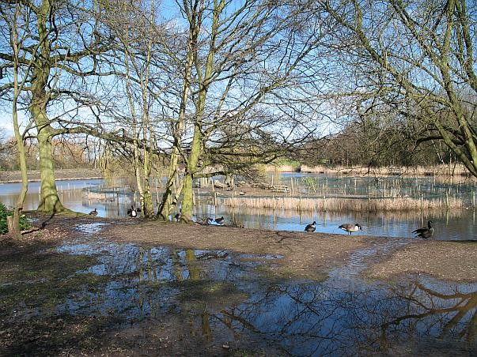
There have not been many pictures decorating this blog lately. I almost feel like renouncing photography as a means of trying to capture the world’s beauty, because it cannot reproduce the glowing mysterious surfaces that I see. It’s not long since I renounced being a therapist. That was a minor liberation in itself. On one hand, it was a vehicle for compassion; but on the other, that very compassion could be deadly, both to me and the patient. It feels good to abandon that pretension. Writing is the only medium in which honesty and artistry allow me to convey my perceptions. I see them as snapshots of the world, which ask to be developed and printed, so that they can be given back to the world, for that is where they belong, for they are part of it.
Photography and therapy have one thing in common. they choose something on which to focus and leave the rest. Increasingly I choose the choiceless: a word I have learned to love. I hard it first in a poem “in voiceless laughter and in choiceless gesture then”, as in a poem by Lawrence Ferlinghetti evoking San Francisco in 1950, with the single image of a woman hanging out washing on a hillside overlooking North Beach. “Choiceless”: not a synonym of “unfree”, but a transcendental form of freedom. And I ask, what is poetry but crystallized memory, yours & the poet’s, mingled?
I went to a park, Babylon’s Mill Pond. (Babylon is my code name for the “new town” where I work.) I found it almost perfect, but time will enhance its charm further. Good intentions at the town planner’s drawing board are one thing. Over-conservation by the park-keepers is another. What’s already started now, and just needs more time, is natural weathering, overgrowing, graffiti, a little vandalization. Then we will have a better harmony of nature, divine and human. Paternalism and teenage rebellion will joust, meet their match and agree to differ.
The pond is edged with reeds and a boardwalk, from which jut fishing platforms. Various varieties of ducks, geese and aquatic plants are given sanctuary here, protected with netting and other works. Trees have been recently lopped and pollarded to within an inch of their life, like an army recruit’s first haircut.
The pond fills up from culverts artfully positioned to cascade water down concrete steps, and as the sign proclaims, it’s a “balancing pond”, designed to fill up quickly after rain; releasing its excess waters gradually into the sewerage system. It’s a short stroll from MaxiRam Castle, code-name for the tall building where I work.
Something more than a blog is germinating: a real book has become a gleam in the eye of its begetter and I give it the provisional name Mill Park; for the ideas springing forth from just one walk round the pond could fill a chapter, not just these 500 words.
Whence the secret joy of this walking in landscapes, observing the crusty lichen and graffiti on weathered walls? It’s a puzzle. I only know that my life is daily more vivid and choiceless, imbued with an odd kind of renunciation. I’m not letting go of the pleasures and pains of the flesh, for death will achieve that, without any striving on my part. I’m renouncing partiality for the sake of the whole. I’m renouncing prejudice against myself and others, in order to embrace the whole.

“ce que vouldras”
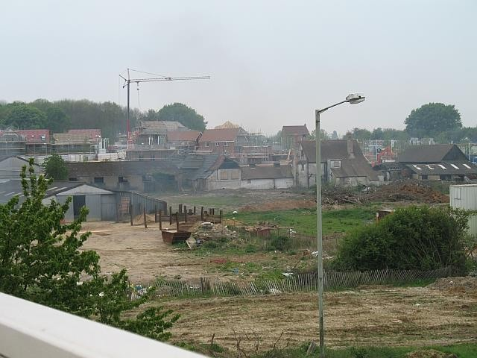
I can see out of my office window to an interesting landscape, though it’s blurred by a film of reflective sunscreen which they’ve stuck on the glass. It’s a view of a new residential development: little houses, roads, flags advertising the Marketing Suite, bulldozers, workers, drainage, dried mud. In the foreground is Peacock Farm, very ancient. They’re taking pains to preserve it. This is England, after all, proud to be ancient.
I escape when I can to explore these exciting places. It would take a volume to record the feelings and memories evoked by their sounds, smells and visual impact. Beyond the building-site runs a highway, with a railway line running parallel, which I hardly see now that Spring has put leaves on the trees. The horizon is made of an artificial ski slope, with what looks like two spires behind it, the ensemble like a mythical castle. I must go and see it close up. But as in a fairy tale, there are obstacles to overcome.
A colleague invites me for lunch in the staff restaurant. As soon as I can, I skip out carefree, seeking a path to the fairy castle. I discover a little underpass which tunnels beneath the highway, runs beside the rail track, finally giving access to litter-strewn footpaths, which take you to places grand and squalid. There’s a recreation park for Hewlett Packard, with special jogging routes and tennis courts. It looks exclusive. Signs warn me to stay out, or else the CCTV will see my misdemeanours. I imagine them sending polite security-men in grey suits and dark glasses. Then there’s a public recycling tip with the unusual sign, “No pedestrians”. I imagine being accidentally bulldozed into a machine that compresses garbage.
———
The following day I try again, this time over a rusting iron footbridge, talking to myself via the dictaphone. Francois Rabelais is on my mind. His character Gargantua founded the Abbey of Thelema, whose motto was “Do what you want”. Rabelais wrote in the early 16th century, when religion was in turmoil like today, with a great confusion of ancient authority and manifest corruption. You could see the Reformation gathering force like storm-clouds filling the sky.
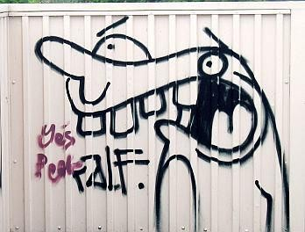
I’m glad to see the cheeky graffiti of some rebellious artist. I meant to talk about this philosophy of “Fay ce que vouldras” but it’s reluctant to express itself and I’m glad really. It has no need of formulation: just to be felt and lived. My true nature can be trusted to know what to do, so long as I stand on the bedrock of my uniqueness. I remain vulnerable and exposed in this world, but angels protect me. They can be trusted too.

impulse
For several weeks, dear reader, I’ve had nothing new to say. Were this a movie, my wordlessness could be wordlessly conveyed. Here is the fragment of screenplay:
The scene opens to a man turning the platen of his typewriter to feed in a fresh white sheet of paper. Surrounding him are bookshelves on all sides. He stares at the blank sheet. After much fidgeting and sighing, he starts to type intensively, one page, two pages. . . . He looks pleased, goes over to the sofa to lean back and read, his glasses pushed up out of the way, the paper held four inches from his aging eyes. On his face we read a five-act drama: eager expectation—intense interest—satisfaction—puzzlement—fury. This last act is violently depicted by his screwing up each sheet in turn to fling it inaccurately towards a basket already overflowing with similar projectiles.
He paces the study in his silk dressing-gown. Tracking his field of vision, the camera sweeps across the packed shelves, allowing us to see the titles of some portentous tomes: the Holy Bible, Boswell’s Life of Johnson, Letters of T.E. Lawrence, Letters of Vincent van Gogh. . . . It pans rapidly across more titles before coming to rest at a series of slim black volumes with numbers down the spine in gilt. These are his journals. He pulls out one, then another, going through the pages impatiently like a bloodhound following a trail. Ah, here is an entry which interests him. The camera zooms in to show us the hand-written date: 13th May, 2007. The mood of the scene becomes a little brighter, more colourful. Background music suggest Spring, or a new beginning. Wordlessly, it’s conveyed to our subconscious that the source of freshness and originality may be discovered from our own past.
He takes the journal over to his desk, where a green-shaded lamp throws down a small pool of light; and sits. We see the precision of his eye as he reads: scanning, frowning, ready to pounce like a bird of prey. We see the precision of his hovering pencil, the sharpness of its point as he annotates the page: transposing words, changing punctuation, crossing out three sentences, scribbling a replacement in the margin, with a snaky arrow indicating its insertion point. He does all this with a light touch, like a schoolmaster commenting on the essay of a promising boy.
He takes it to the typewriter, starts a clean copy from his revised journal entry. We hear a merry clack of keys, which fades as if with distance, while we dissolve to a cloud-streaked sky, just before dawn. A typescript rolls slowly up as we read:
13th May 2007
For days the art of writing has evaded me. I had no subject-matter and no impetus. The other day a man asked me to write his biography, and I almost took it seriously, for I had nothing to write on my own account, just an imagined vocation. I’d reached the point where I didn’t want to step outdoors, for what was the point? Without some spur, you can’t take a leap into motiveless freedom.
Then this Sunday morning early I went out to post a letter then as soon as I got out the door, open air enveloped me. Its sensual immediacy was unimaginable from indoors: this unspoilt sharp air of dawn, its steady fine drizzle from low clouds that painted the sky with a uniform pallor. As I type this I’m inches from that open air, for my desk faces an outside wall: inches away and I still can’t imagine it.
Reality is that which cannot be imagined: the thing which impacts our senses directly. So how can a memory-stored image of long-ago, a realistic fragment, if you will, be evoked by the here and now? Evolution must have laid down the link, this pathway in our brain. An ape catches a whiff of distant fruit on the breeze. It triggers the long-stored memory of eating its sweet flesh, and sends him swinging from bough to bough through the forest.
Air is the linker. I pass through deserted streets. Across the rows of rooftops, air brings me birdsong echoing across the rooftops. Its transparency—which I normally take for granted—reveals these rows of humble dwellings, once factoryworkers’ cottages. One catches my attention with its peculiar pathos. Makeshift curtains have been roughly drawn across to blot out the morning light, all windows tight shut to keep out the air. I imagine its occupants snoring oblivious inside.
It’s this unimaginable reality which impels me to write. It can’t be described but I’d wish to point in its direction. As I left the house earlier, there were snails on the wall, extending their eye-stalks and feelers in gratitude for the rain. Can creatures express joy? Why not? And why should they not enjoy the beauty of their own being? I took a snapshot of one.
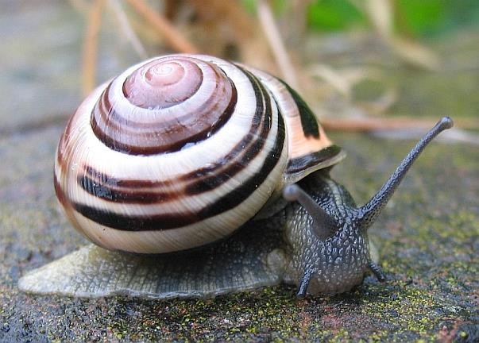
It was only out in the rain that I could remember the important thing. The essence of wayfaring is to go aimlessly, in pursuit of nothing but reality, a substance so plentiful that it matters not which way you go.
One could sit indoors and say “This is not a day to go out. It’s raining.” That’s what imagining does for us; no, what it does to us, for it does us no favours.
Reality dies every moment, replaced by new reality. The pattering of rain on the leaves is an age-old music, but the erratic clanking when it drips from a roof on an iron fire-escape is modern. I hear the hushed roar of airliners above these clouds, carrying travellers waiting to land at Heathrow Airport, twenty miles away.
Says William Blake, “Eternity is in love with the productions of time,”

dishonour
I set out on my errands, hardly reached the street before ideas started to flow: something to ponder, something to write about. I swiftly reviewed the range of human belief systems: from burnt offerings on rugged mountain-tops to communal church attendance (booking a place in Heaven) to New Age superstitions, such as “we create our own reality”. A thought came in a flash, between two lamp-posts, as the familiar street swivelled before my unregistering eyes and the world went about its business, weaving back and forth, with motorised wheels carrying the “well-heeled” in the thoroughfare, leaving the rest of us, modestly-heeled, on the sidewalk.
This was the “universal revelation” that I had in that moment. I saw that we each strut the same stage, perform in front of the same backdrop. In the present case, it was this street, Victorian houses one side, workshops on the other, traffic lights ahead, the sky above. We don’t just have different parts to play. We dwell in hallucinatory realms of our own unconscious devising, made up of compulsive ideas. They’re like tinted lenses, rose-coloured spectacles perhaps. Or you might say that we live in a bubble of filtered perceptions.
That was half the flash. The rest came straight after—I still hadn’t reached the second lamp-post. I saw that this bubble is created for our protection. We have to cushion ourselves from death, and all the little daily disappointments. We have to tell ourselves it’s OK. Every gain is threatened with loss. Everything will be swallowed up in the big loss, the final one, the only endgame in town. And since we are all subject to the same imperative, we might as well tolerate one another’s bubbles of belief, or to put it more bluntly, the lies we can’t help telling ourselves.
And now I find I’ve used the pronouns “we” and “us” in a universal sense, covering all mankind. I do it rarely, for I’ve no right to speak for everyone. The highest I can aspire to is speak honestly for myself. Back to me. I was on an errand to get a haircut, bring back a loaf of bread.
The source of anxiety is always “me”. Ego tells me to watch out for myself, that’s its proper role. I stood at the traffic lights, waiting for them to change,
“Will the barbershop be busy? Who will cut my hair? Should I have waited another week? Is it already too long? Will I have to make conversation, or will there be an awkward silence? What if they cut my hair badly and overcharge me? Will they expect a tip? Will it be an old man or a young woman?” You’d think it was my first time.
Now I was 200 yards away from the barber’s. I’d spent more time worrying about the haircut than the enigmas of life, death and human separateness. I suddenly recalled being five, running out of a barbershop screaming. It was my first visit to London and I did not trust Londoners. I was still a cheeky little Australian. Perhaps the barber said “Sit here, boy” in a gruff voice. Perhaps I was scared of the razor-wielding I witnessed. I cared not what anyone thought. I was prepared to ruin everyone’s day with my screams and tears. They gave up trying to get me to go back in.
Yesterday’s haircut was all right, of course. The young woman was so quiet, I tried to start a conversation, but she didn’t understand. Turns out she’s Polish, hasn’t been here long. She offered me a pensioner’s discount but I got out of there feeling not too damaged, just self-conscious of with my new short hair, feeling older than when I went in.
I remembered to buy the bread. After some indecision, I went to a small grocery where there’s little choice and everything costs more, called Costcutter. When I got inside it seemed a bad idea, but I was the only customer and felt sorry for the shop assistant. So I bought a sliced loaf in its own garish wrapping, refusing the offer of a further bag for vague ecological reasons. So I had to walk out displaying my purchase for all to see. For some reason, people don’t do that round here.
It felt a little awkward, I didn’t know why. Where’s the shame in dangling an undisguised loaf of bread, when your head is newly shorn? I felt I had to put on a defiant air. If a sword had been trailing at my side, I’d have grasped its hilt with my free hand, to make sure no one gave me the wrong kind of look. In days gone by, the wrong kind of look can lead to a challenge, and maybe a duel. In certain pubs it still does. Whence this instinctive notion of “Death before Dishonour”?

greeting strangers
Place does affect the way I write—maybe the tone—but it always has an influence. Does place matter in your work?
Poet Scot Young asked this question in his blog and I said yes. When I go walking, thoughts come to me, and they seem to resonate with the sky, trees, roadside litter, sounds, everything. I thought it would take a series of essays to amplify my “yes”.
Time comes into it too. My best is the early morning and ideally I’d be abroad on highways and byways as the sky lightened, ready to greet every dawn. One wants to squeeze everything into one’s time of greatest strength and alertness, so it’s not easy to get out the door, but last Friday I managed it by eight, with camera and voice recorder as surrogate friends to share the experience. This is the tale I bring back.
—
There’s a fresh breeze and it’s damp rather than cold. A weak newborn sun lights the hurrying pedestrians on their way to work. I pretend the cars are not there and I’m in the nineteenth century. It works pretty well except when I have to cross a road, when self-preservation takes priority.
K has lent me a pedometer which she got on loan for a week from her employers, the National Health Service, that symbol of socialistic kindness which blesses her Majesty’s subjects with its concern for their wellbeing. 10,000 steps per day is recommended. Let’s see what I do on this walk along the Wye Valley to Loudwater.
The ground is covered with fresh-fallen leaves. For a moment, I wonder why they appear so poignant, like fresh-fallen snow. I imagine a small child seeing them for the first time; and then a man in the autumn of his life remembering every Fall since he was old enough to walk, especially the first time he noticed the leaves stuck damply to the sidewalk; or dry crackling ones windblown into thick heaps that he shuffled noisily through, holding a parent’s hand. I call him Everyman, and I know that I am he.
After the first mile, I leave those streets with their streams of workers, and go diagonally through the park, reaching the trail of public footpaths which penetrate every obstacle: woods, meadows, housing developments, factories. There used to be several papermills along this valley, powered by waterwheels, one of which has been reconstructed out of a respect for history. On special occasions they use it to grind a few sackfuls of wheat, but mostly it lies silent, desolate, the millrace diverted by sluice-gates.
———
The word Freedom comes into my head. I suppose in the recent Presidential election it was a word of mystical power. I can understand how it would still be so—to one chafing in servitude. Why is Freedom still a slogan to those who see themselves as already free? They feel burdened with the duty to defend it. I had another “universal revelation” Everyone acts to protect what’s sacred in their society. Attack that and there will be a fierce response. “Submission to the will and laws of Allah is the source of all freedom”, says Islam, which means “submission”. Two definitions in collision.
For some reason I have always found it easy to identify with the downtrodden, and have little sympathy with the powerful. I don’t mean to attack freedom, or any other concept of the sacred: just to scrutinize it. I think of a peasant as freer than an ambitious office-worker, but that’s just my bias. I’m in a meadow, closely following the meandering river. On the other side are newish apartment blocks, with balconies and neat communal gardens. They need no fence because the water makes a natural boundary.
I think about Americans, in a week momentous in their history. They seem like an Old Testament people. We only hear the Israelite side of their story. The Philistines and followers of Ba’al would have had their story too: their own myths, their own heroes and tales of inspiration, but we don’t know them, only winners’ history, somehow pasted into the scriptures of two separate religions.
The things that matter to a tribe are often encoded within a religious belief-structure, that may seem like superstition or prejudice. It is not surprising that in a progressive society, the urge is to let rationality sweep those things away, ignorant of the precious secret: that the sacred is hidden, wrapped up in the mumbo-jumbo. What is the sacred? It’s something revered because it is necessary for the healthy existence—and coexistence—of mankind.
———
I move to another branch of the river which has squirrels dashing along the path to take the bread and seed which people had scattered to feed the ducks and swans. I encounter a rat near the place where the river disappears into a culvert. It regards me coolly with whiskers a-twitch before going about its business, in no particular hurry. Being classified as “vermin” and unworthy of humane treatment hasn’t made it hate or fear me. Its forebears spread bubonic plague throughout old Europe. In this moment, looking one another warily in the eye, we’re of equal stature. Sailors once spread syphilis; missionaries once spread the idea of sin and redemption to savages who were fine without it. As species, neither of us lives on the moral high ground. Brother Rat, this is a liveand-let-live-moment. I wish you and your family well.
I pass through meadows, paths, the alleys between the backyards of suburban houses, and reach the embankment of a disused railway line. Nearby there’s a waste-water treatment plant which collects from a big pipe and pumps effluent into the river. It’s good to see the infrastructure of this town, and I pass all kinds on this walk: red Royal Mail vans, postmen on foot, electricity transformer substations, gas distribution, water, and now sewerage, which I feel moved to photograph. It works for us invisibly, we depend on it: like someone’s idea of God. The sewerage system and all who work on it deserve my gratitude.
———
I’m on a narrow footpath now, beside a bit of river straight like a canal. I’ve been here before, one steaming August day after rain. The wet undergrowth gave out aromatic exhalations, principally from the luxuriant Himalayan balsam, an invasive species which has escaped into the wild. “The aggressive seed dispersal, coupled with high nectar production which attracts pollinators, often allows the Himalayan Balsam to outcompete native plants.” Today it’s warm for mid-November, but riverside weeds are in decline, saving their strength to survive the coming winter.
———
Where was I? The sacred. Locked up like a seed within the pod of superstitions, posturing and corruption, there is something lively and noble in every culture. Never mind the axis of evil. Here, on this fresh morning, in this valley, it seems totally clear that our leaders should talk to Al-Qaeda and Taliban, face to face. Then we’ll discover we are exactly like them. We have our ideas of the sacred, which we feel to be threatened: so do they. Has war any other cause?
Enemies should approach one another bearing gifts, ready to listen and be magnanimous. The conflicts would evaporate. That is exactly how the derided “savages” used to do business.
———
The footpath takes a zig-zag route through meadows. Then there’s a recreation-ground where dogs take their owners for walks, and lift their legs against goalposts; and now an overgrown alley between backyards and warehouses. The alley debouches into a suburban development of modest houses. In the UK it seems you can’t build over public footpaths, even though you’ve bought the land. The law makes them immortal. There’s one called the Ridgway Path which dates back several thousand years. Only a terrible calamity would erase these footpaths. First to go would be motor-vehicles: supplies of refined oil would be cut.. Then the complex infrastructure: mail, electricity, gas, piped water, sewerage. The supermarkets, presently bursting with food like Christmas every day, would empty and become derelict, their perished remnants left to the rats. Footpaths will stay, like King Arthur waiting dormant till they are needed to save Britain once more.
One day, clinging to my final breaths, I may wander these neglected paths one last time, bidding them farewell—of course only in memory, if that hasn’t been wiped already.
Whilst I’m getting carried away on this fantasy—footpath as symbol of eternal reality—a couple of elderly ladies approach from the opposite direction. It’s a narrow straight path passing between backyards on either side. There’s something unexpected about their greeting. It seems to carry joy. I am no more ready to commune with “Perfect Strangers” than I would be to meet a favourite great-aunt, long departed, whom one of these ladies fleetingly resembles. I find myself tongue-tied, only able to mumble something conventional; still, I can share their smile. It’s as if we are in church and it’s that point in the liturgy they call The Peace: “The people stand and greet one another and exchange signs of God’s peace in the name of the Lord.” It’s like meeting the stranger on the road to Emmaus.
I had no words for those ladies then, just these for you now.

thankful
“What are you thankful for?” asked a blogger friend, seasonably, it being the festival of Thanksgiving over there. What shall I do with the days that remain, if not give thanks? For the birds that sing in my backyard. For everything.
———
I always go to meet my wife at her office in the hospital, at the end of her working day. It’s a twenty-minute walk each way. On Thursday I muttered some words into my voice recorder on the outward journey. This is an edited transcript.
“… to capture the very essence sometimes of what is going on in this world at this moment. I’m sure that what we see is a reflection of where we are at. I see cheerfulness, despite the debris and desperation. There’s always reasons for those. This morning in the playground—my shortcut into town—a man was sitting on a low wall, hunched, head sunk on his chest, motionless. It looked like despair, but for all I know it could have been a meditative ecstasy. The beer can in his hand and the dishevelled clothes admittedly cast doubt on this hypothesis, but it’s hardly for me to judge.
“My perceptions are detailed and precise. They consist of sensations, thoughts and emotions. You may call these three different realms, but they are not easily separable in ordinary life. The senses too are separate realms whilst usually all active at once. Here in the twilight I note a hedge bordering a front garden, rigorously pruned but apparently covered in pink blossom, flourishing in November; but I can only guess its colour as the sky darkens, and I don’t slacken my pace. I’m a creature totally alert: for this I give thanks. I observe with all my senses and think too, trying to classify this botanical phenomenon, taking into account the time of day, the time of year, possible optical illusion, my memories of similar phenomena; whilst the cold wind, and the faint combination of scents that it carries, all form part of what I observe.
“I’m thankful for the sky. It’s still above, always putting on a display, whether it be fantastic cloud-shapes, fathomless blue, dazzling sun or impenetrable night. In this well-lit town I seldom see the full pageant of stars, as one would see in the desert, or I once saw when bivouacked on the Isle of Wight Downs. We sat round a circle of dying embers and ash, gazing in wonder at a hundred shooting stars.
“I pass down a street with houses either side. A smell of stewed beef hangs in the air. A Chinese man emerges from his house for a smoke, followed by two little dogs, who look Chinese too. I don’t mean they look like the man: more like mongrel versions of Chinese dog breeds (Pekinese, Chow). In the privacy of my thoughts I wonder if these are the dogs which are bred for cooking purposes in China. The man glances at me as if reading my thoughts. That’s the thing: it is all right to observe the world of Nature as if one were an outsider, like Hesse’s Steppenwolf. But I must suppose that people are more “psychic” than common reason acknowledges. Perhaps I must not even think “racist” thoughts. Now I hear a yapping behind me. Did the dogs read my thoughts too? A young black man walks towards me, so tall, striding so powerfully. There is more than rhythm in his stride: there is music and dance too, I don’t mean literally, for he carries no iPod, only music pulsating in his veins. Life is so interesting! If it were really the case that I could have an influence on the world, to give something back, I would gladly respond to a vocation of sharing this immediacy of experience: not to entertain others but encourage them to find it for themselves. This intensity, immensity, without drugs!
“Now I’m behind two little children who stepped out of a car in absurd school uniforms—blue blazers two sizes too large, skipping along in front of their mother. The girl is smaller, wears thick red stockings and her footwork fascinates, for it’s uncontrived, not intended for any audience. Maybe she goes to ballet class, maybe not.”
———
Does everyone experience such things? I may not presume one way or the other, but give them the benefit of the doubt. I wonder if the Piraha tribe of the Amazon see the world as I do:
“Piraha problems with reading, writing, and arithmetic stemmed not from slow-wittedness but from a cultural conviction about how to converse,” Everett proposes. From the villagers’ perspective, talking should concern only knowledge based on one’s personal, immediate experience. No Piraha refers to abstract concepts or to distant places and times.
Moreover, the Piraha tell no creation myths and don’t make up stories or draw pictures. They believe in spirits that they directly encounter at times, “but there’s no great god who created all the spirits, in the Piraha view” Everett says, and adds:
Cultural mandates to express only one’s immediate experience and to shun outsiders’ knowledge have kept the Piraha population, which now amounts to around 200 people, from learning other languages despite more than 200 years of regular contact with Brazilians and various Amazonian groups.
(From an article on the work of linguist Daniel Everett.)
———
I can’t imagine the inner life of a Piraha. I cannot imagine the inner life of a stranger I pass on the street. I give thanks for my own, and also the blessings of counting, reading and writing.

Basho
If a blog can merit its own patron saint, then I choose Basho, wayfarer and Zen monk equally famous for his haikus and his travel writings in prose:
“Days and months are travellers of eternity. So are the years that pass by. Those who steer a boat across the sea, or drive a horse over the earth till they succumb to the weight of years, spend every minute of their lives travelling. There are a great number of ancients, too, who died on the road. I myself have been tempted by the cloud-moving wind—filled with a strong desire to wander.”
I went a little further afield yesterday, drawn by two attractions in the same vicinity. One was marked on the map as a huge sewage works. (Previous posts testify to my choice of sewage works as a pilgrim destination. At any rate they remind us we are not all spirit.) The other attraction was, to my mind, unquestionably a place of world-wide interest and literary pilgrimage, immortalized in the introduction to the Hitchhiker’s Guide to the Galaxy in these terms:
And then, one Thursday, nearly two thousand years after one man had been nailed to a tree for saying how great it would be to be nice to people for a change, a girl sitting on her own in a small café in Rickmansworth suddenly realized what it was that had been going on all this time, and she finally knew how the world could be made a good and happy place. … Sadly, however, before she could get to a phone to tell anyone about it, a terrible, stupid catastrophe occurred, and the idea was lost for ever.
This is not her story.
I decided to start near the sewage works and walk to Rickmansworth in search of that café. The journey, as it turned out, was better than either of the destinations I had chosen: for my walk took me along the towpath of the old Grand Union Canal, whose narrowboats have become permanent or holiday homes. Woodsmoke came from the chimneys of some of them. In the old days the canal revolutionised transport, towing goods between London and Birmingham as a much more efficient use of horse power than wheels on roads.
Suppose I am given the rest of my life to do nothing significant, simply to go a-wayfaring, to contemplate existence in places as peaceful as this, and whatever places appear on my route? Then I shall have time enough to discover something, even when I have no idea what I’m looking for. And if this notion of discovering something worth writing about is just to lend spurious meaning to my idler’s life, so what? The destination is merely a pretext, as it was by the canal, as it was with Basho’s journeys through seventeenth-century Japan.
I hoped to take some photos. The sewage works was mighty, but shrouded in trees from where I walked. I saw a magnificent scene involving two tiny tugs and a team of men lifting an old barge with a crane. Then there was a derelict factory, reduced to a skeleton, with what looked from a distance like two naked dwarves winched up on a hoist swinging gently, silhouetted against the sky. When I got close enough I saw it was some kind of cartoon animal, almost lifesize. I didn’t take pictures of the bargemenders or the stuffed toy. I told myself to but my fingers didn’t obey. I deferred to their wisdom and kept on walking. I found no café in Rickmansworth that could possibly have inspired Douglas Adams to base his scene there. Had I done so, I would have sat in it, like his fictional girl, and tried to tune to her idea of how the world could be made a good and happy place. And I would have told it to you first, dear reader.

archaeologist
I had intended to take my well-trodden valley path, a fruitful place for broodings which I’ve several times described here. But a different plan revealed itself on the way. The first leg was accompanying K to her work at the hospital, about a mile away. After we said goodbye I passed through the back gate on to the main road down the hill. At the front of Maternity stands an old boundary wall. It’s not pretty but seemed to glow with meaning, as if I suddenly discovered a different way of seeing. Sometimes it happens the moment I walk out of the house, and I used to think it was the ultraviolet rays, the birdsong, the fresh air or the clouds. There’s nothing more plain than a dull grey concrete wall. It was just a matter of getting on the right wavelength and it happened in that moment. Suddenly I thought of shamanism and the special kind of seeing taught to Carlos Castaneda by his mentor Don Juan; I decided to go where my feet and eyes led me, not a predetermined trail. I was carrying a map but used it only to avoid getting lost. How could it guide me where to go? I’ve stopped believing in guides. I have to journey alone.
I’m walking up a hill now, cheap housing above me on the right, thickets in a kind of ravine on the left, where I stand above the broken roofs of old sheds. I want to explore them, crawl through this convenient hole in the fence, clinging to branches as I descend, to discover what these sheds were once used for, and see if any treasures remain. I resist the urge, reflecting that I’m half a century too old to be doing that.
I continue through a wide expanse of rough-cut grass: it’s the common land adjoining the estate of council flats, a place for children to have adventures, though deserted at present. A child’s homework diary has been torn from its loose-leaf binding, its pages now wind-blown over a wide area. I pick up one or two for close examination. Archaeology fascinates me, it doesn’t matter how recent the artefacts. There are notes from teacher to parent; from mother to teacher; from pupil to self. There’s an appointment to see a welfare officer, and a note from the officer apologising for keeping the boy late.
I mentally compose some anthropological notes: In this ravaged landscape I have found a valuable picture of life in the year 2009: how tribe members worked communally to impart traditional lore to their young, sending messages with coded squiggles using various dyes marked on sheets fashioned from wood-pulp. Do not imagine the homo sapiens of Britain to have been crass and ignorant, for these well-preserved “Homework Pages” provide convincing evidence of a fascinating culture. One might almost call it advanced.
I’m in the mood to notice everything: expressions on the faces of dogwalkers and their dogs; litter—sometimes dismembered toys, but mostly snackwrappers, cans, plastic bottles. From which we can deduce much about twentyfirst century diet and the social norms of their civilization.
I pass Hillary Road, where twenty years ago, I had the intuition that my father (whom I had never known, or even known about) was still alive: a correct intuition, as it later turned out. A mile or so later, I enter King’s Wood. I’ve written about that too. Three years ago, police conducted an elaborate search for bomb-making materials, lasting weeks. A plot to blow up transatlantic airliners has been discovered. Any sign of this intensive activity has now grown over. The place is litter-free. I’m careful to hide my banana-skin deep in a bush.
After an hour and a half of vigorous walking, I get “second wind”: an interesting phenomenon written up in Wikipedia. They don’t have a definitive explanation, I’m glad to say: I prefer mysteries. I get into an easy rhythm, I feel I could walk all day, and was born to walk. In fact I was, it’s a gift of evolution, or if you prefer, of God—via evolution. I might be a descendant of Ötzi the Iceman from 3300 BC. “By examining the proportions of Ötzi’s tibia, femur and pelvis, Christopher Ruff has determined that Ötzi’s lifestyle included long walks over hilly terrain.” (Wikipedia). I enjoy walking for five hours at a stretch, but hate to sit down at a desk for more than an hour. [Subconsciously, I’ve colluded in making my desk uncomfortable: the sharp table-edge almost cuts my forearms as I type; my bottom aches on the plain wooden chair.]
What happened at the grey wall, when it seemed to transform into the pearly gates of Heaven? Wayfaring is my meditation. When I leave the house and walk alone, I turn my back on “cares”, and open myself to membership of the “All”, the Universe. It doesn’t need pretty scenery, so long as I allow sensual inputs from all around to stream into my consciousness. Not just those from all around but those from my own body too—bones, flesh, guts; whether my legs feel heavy; feeling hot or cold; sweat, pain or fatigue; insect bites, grazes, aching joints. In short, whatever happens, saying “Yes!” to it.
I don’t want to say that wayfaring is a method to achieve something. Does it need to be mapped? Maps are good to prevent getting lost, that’s all. They can’t tell you where to go.
Here in the stillness of these woods, with birds echoing across the clearings and strange sounds—clickings, creakings—I pick up quite a different sense of what it is to be human. A sense that links to dim memories of the past, and not just early childhood. It’s a good feeling, that’s all I can say. In writing, I try to be a voice in place of the silence from the others I encounter, or might have done, centuries ago: joggers, workers, peasants, dog walkers, everyone who follows paths in wild places like our ancestors the hunters, or Ötzi the iceman; those who touch Nature and let themselves be subsumed in it; yet don’t have the words. I don’t really have words either. They have to be invented.
There are enough books, I don’t want to compete, but just give a taste of what it is like to be an ordinary person. And you may ask why, because ordinary persons know already what it is like. Ah, but this other evolutionary gift, this organ called the imaginative mind, gets in the way, allowing us to deceive ourselves, adapt to inhuman ways, deny the facts of our evolution. It’s tempting to follow the fake culture and forget deeper knowledge.
I write to remind and undeceive. That is what impels me to write about ordinary things. Here on this last day of June, in the shade of this footpath which cuts through another estate of cheap houses like a sharp knife (it was here before the houses and is protected by law), I feel enormous privilege. I came with no purpose but gratitude for the gift of legs. I don’t know what else to say. This is life and I am glad to be part of it.

unto the hills 2
“When I was someone else, that I am not now ...” continued from my
last.*
Let us assume that each one of us contains multiple personalities. Vincent exists in the written word, is not quite the same as his author, who inhabits other dimensions never written down. Vincent is several persons, separated by time-slices, spliced together into fragments of literature.
Here is a new garment fabricated from a voice-recording of the wayfaring Vincent; stitched and embroidered by seamstress Vincent. Both are merged in a single “I”; but the personal “I” is a fragment of the universal “Everyman”, in which, dear reader, you and I may momentarily unite, till we switch from the illusion of unity back to the illusion of separateness.
I trudge up the hill, with Psalm 121 in my head, to a tune by Beethoven: “I will lift up mine eyes unto the hills: from whence cometh my help”. I don’t know what is happening, except that I let my feet do the walking, and they take me up this hill where I can gaze down at the valley where I live beside the Mosque. Gulls circle round overhead, for they don’t just haunt the seashore. They come inland to this scruffy industrial town where junk food remnants are strewed on road and pavement. They swoop down to clean up what is supposedly harmful to humans, but evidently produces graceful birds.

* Refers to a post not included in this edition.
You can get a good view from here, but photography {I might have said “topography”} gives no clue to the reason for undertaking a climb this steep. I don’t have a reason. My indoor thought, before I tasted the fresh air, was to take the valley path and save my legs. That way I can walk miles. {sound of panting} But when I let my legs take me where they want {indistinct mumbling} . . .
Up here, higher, I see more red kites in the sky than ever before. These birds were almost extinct a few years ago. I think someone up here feeds them meat scraps. There are eight, their flight is different from gulls, they float on the thermals, their great wings stretched motionless; but I can’t see them all at once, have to crane my neck round to count them.
My legs are like pendulums, swinging effortlessly to where they want to take me, gaining a special strength from obeying their own will, not my mind’s.
This is what a wayfarer does. Like an animal, he follows his instinct. He trusts it.
My mind doesn’t understand the territory this takes me to, when my feet go their own way. But there is no reason why my mind should not learn to understand.
{I felt it was a kind of shamanic journey, one I was learning slowly, without a teacher: how to enter a different world, not in a trance, but in a state of mind unsuited to the struggles and complexities of external life in 2009}...
I pass the home of a friend . . . {interrupted at this point by a passer-by, asking for directions. I switch off the recorder.}
A young man accosts me, asking if I know where there’s a chip-shop. “Yes,” I say, “you go down that road, till you see a pink stretch limo, if it’s still there.” {Yes, they do occur in this country, always left-hand-drive, imported from the States, and hired out for weddings and suchlike}. “You’ll come to a little row of shops, including a Chinese take-away that sells fish and chips.”
I enter the “Disraeli Wood: National Trust”. I’m looking for the Disraeli Monument. But in no time I get lost, as in the beginning of Dante’s poem.
Midway along our road of life I woke to find myself in a dark and secret wood for I had lost the narrow path.
Perhaps my feet will take me into some metaphoric Inferno. Everywhere I look, squirrels dash for cover against my approach. Few birds sing: it’s eerily quiet. In the distance I hear a dog barking persistently. Perhaps it is Cerberus and I am entering the underworld. I descend through a kind of shallow ravine. Surely there will be a path, and it will take me somewhere. Never mind the Monument. I’ve seen it enough times.
Four years after the instantaneous cure of my chronic illness, I can walk anywhere, without fear of sudden exhaustion. So today I celebrate the conquest of fear, letting my feet dictate the journey. A small sign tells me I am on the National Trust “Boundary Walk”. I’ve never been this way before, but it’s a good path. Now it emerges from the wood to a vista of fields and rolling hills.
{This metaphor didn’t occur to me at the time, but all my Wayfarer’s Notes have been boundary walks. Each new post sets a new boundary. I’m interested in the edges of experience, not the obvious mainstream.}
And I see that {pauses} . . . all my writings till now . . . have been just to get things out of the way so that, just as today I let my feet choose their route, my fingers, as it were, will choose what to write. I’m inspired enormously and subconsciously by the pathfinding lead of Fernando Pessoa. We journey on—I mean, I hope you’ll come with me.
I’ve used this blog sometimes to practise writing, sometimes to try and tell all: everything that happens now, everything I remember from childhood, even when it was painful—and much of it was. {I meant to add that it doesn’t matter now, let the memories go unrecorded; perhaps one day they will be unremembered, by reason of dementia. But there is always more. The Creator endlessly creates. Let me endlessly rejoice in today’s new Creation.}
And now, I think of immortality, and not only don’t believe it, but don’t feel any need for it. I shan’t be immortal, not in soul nor in works. To be erased completely, leaving no trace, will be fine. Pessoa left his writings in a trunk, to the mercy of fate. As it happened they were discovered, edited, published, translated. I’m grateful, for he’s shown me how to put things into words which I never thought possible.
{Here it was as if my aimless journey—aimless to my mind, instinctive to my legs—reached its destination: a central paradox which I felt solves the enigma of immortality . . .}
Every moment is so full that it’s no sacrifice to let it go. This is life’s bounty. Those who experience a few grains of gold, painfully panned from the river of time, in which it is far outweighed by mud; those are the ones who hang on to life, and yearn for immortality. But those who have seen the infinite in a moment, who see that it’s no mud, but gold and jewels, every bit of it, constantly renewing itself, a kaleidoscope—how could they fear death?
{I didn’t end there, I droned on about this and that—the imminent rain, features of my route home and so forth. Now Vincent the seamstress, the whereforer, takes out the scissors and lets the unwanted fabric drop limply to the floor.}

space & time
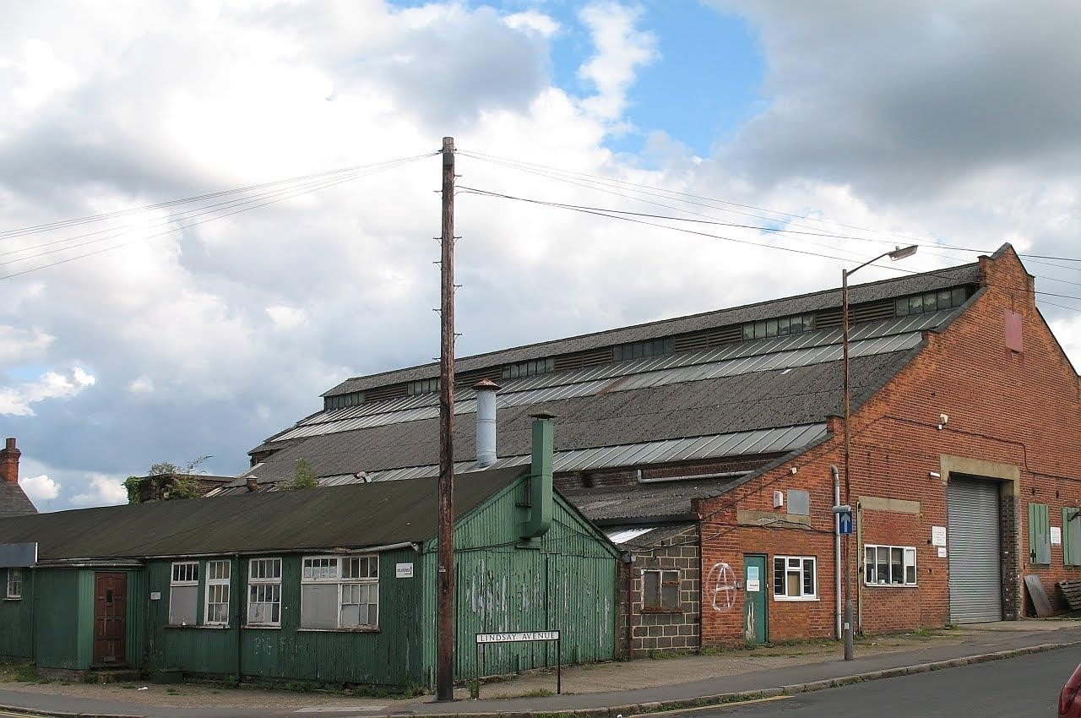
This is the day I become clear about the purpose of my purposeless journey. Now the task is to express clearly that which I see clearly. My path leads more to the past than the future, for “the past is my treasure” as an archaeologist might say.
{I’m examining the imperfect layers of memory, typed notes and voicerecordings of two weeks ago—history already!—when I took to the road as a wayfarer, on a path meandering through a landscape whose views stretched to a far horizon of inner space.}
On this sunny morning in early March, the route I intend to take towards that place is not just some random dotted line on the map, some spontaneous navigation of public footpaths through town and outskirts; but to walk with an hypnotic rhythm, and slip into a mapless dimension. I pick up the flavours of the day: someone scraping up something with a shovel, the smoke of something indefinable burning, a distant siren, cars swishing past me, the sunshine smiling on the houses and workshops of this industrial valley, all built in the last 120 years; some kind of chemical solvent smell (peardrops? acetone?) combined with a hum of machines and fans. There’s a lightness in the air and it’s spring. I don’t hear birds singing but they ought to be, on a morning like this.
Like everyone I have a particular life amongst fellow humankind, with kin and friends and foes and allies and those whom I cannot trust. But on this morning, amidst the whiff of solvent and absence of birdsong, my soul seems to hover at a certain height seeing a different perspective, a wider scheme of things, where this lone biped, the only one I know from the inside, reveals himself a fragment of all, as portentous or insignificant as every other fragment. The hypnotic rhythm of my walking takes its rightful place in the totality. The fact of my walking without a purpose—I don’t know where I am going, when I am coming back or why I am doing this—somehow fulfils my destiny more gracefully than any declared intent. I don’t have to apologise for my apparent idleness to these workers amongst their solvents and machines. They and I complement one another. They work at their vats and lathes, while I stride past in a steady rhythm of walking which induces a kind of wide-awake trance.
Suddenly my trance is disturbed, for I notice the batteries have run out on my voice-recorder, this companion which loyally yet imperfectly captures my outpourings. Batteries running out—in these days the very symbol of mortality, in an age where everything is judged by whether it’s renewable, rechargeable, reusable. Scientists help us to project our anxieties on to irrelevances, such as how many years we have left before the sun goes cold. Shall Nature itself fail, in the end? Is Nature dependent on key components? Can Man wreck Nature? In the face of such questions I can sympathise with those who take refuge in the citadel of religion, grasping at any certainties and reassurances. In human truth, life breaks down into two great facts: mortality, which we observe, and unending life, which we feel. And the fact is that Nature and Energy are indestructible in themselves, even when the sun goes cold and life as we know it goes extinct. This is the essence of religion, which rises like Phoenix precisely when reason lays waste with its fire of scepticism. I will die, yet the All goes on. Nature doesn’t need me. As a man swats an annoying fly, Nature, my own physical nature, will squash me: Nature destroying its own with prolific exuberance.
I walk along an asphalt path through the recreation ground. On its verges, the Council have planted spring bulbs, now already in bud, miniature daffodils. It looks as though they used some machine to set them in slightly curved asymmetrical rows like the sweep of a brush on a water-colour sheet. The rhythm of my walking doesn’t stop me from appreciating all this, though it takes me above worldly preoccupations. In the last few months, engaged on a critical project (which had to be delivered on time) I did not feel capable of taking time out to reach this kind of directionless awareness. In those months, my walks had a different flavour. And it has been a hard winter, not conducive to outdoor flights of fancy. Let’s face it: every day, for everybody, the temporal interrupts the eternal. Every escape from mortal fact to transcendence is a miracle.
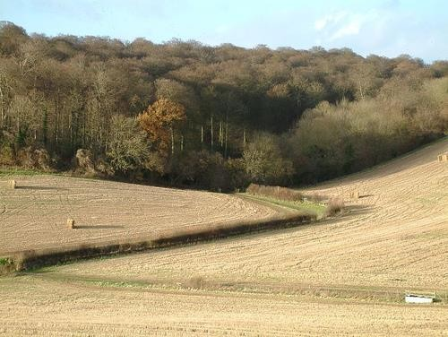
Eternal sounds a grand word. Perhaps I can make do with something humbler, and admit that today’s concerns sometimes move over and allow space for me to go foraging in the past, with memory as the main tool for my excavations. The archaeological metaphor is apt because memory presents only fragments; and these lend themselves to a spectrum of interpretations. When I lightly relive moments from the past, it seems to me I breathe new life into the dead. I flit between the present and the past so easily that the barriers of time seem to disappear, as if I exist at all ages simultaneously. To do this, though, I have to rewrite the past; in the sense of reinterpreting it by the standards of today’s wisdom, which may change again tomorrow.
I treasure this freedom to drift in and out of memory and thoughts of the present, whilst largely not thinking at all, just soaking in sensations of the earth, my mother. I blend with the scene in front of me, and wonder about plants and people and children and powerlines borne on pylons across the landscape, as well as the dirt and litter at my feet—all loosely held together by a philosophy which remakes itself from moment to moment. All these sensations and ideas drift in and out, uncontrolled by any conscious effort. I have no urge to discipline my thoughts. And in amongst them is something more continuous, an underlying rhythm. If I call it the Eternal, it sounds too vague or immaterial, as if in an abstract realm, far away from all this. But it’s not. It’s simply the sum of all that’s laid out before me: a dimly-perceived totality.
Now I’m on the fringes of a wilderness. The far-away squeals of children in a school playground reach me distorted on a gusty wind as I cross a field diagonally up to some hills. It’s an age-old sound, unchanged in all the years I’ve lived, and perhaps for centuries before that. From another direction comes a squabbling of birds in a tree; the voices of birds and the children almost echoing one another. And then the to-ing and fro-ing of trains over there in the valley, passengers and freight, sometimes sounding a horn as they go. Time and nature have accepted the railways as part of the rural scene, as something which doesn’t insult the idyll of these rolling hills and valleys.
I’m on a bridle-path now. There are fresh horse-shoe marks in the churned-up mud. A pile of fresh dung steams in the sunshine. To be on foot rather than horseback seems no inferior thing. For the privilege of sitting high in the saddle, I would have to take on the welfare of the horse, or of the servant who stables the horse. These things would circumscribe my leisure, not increase it; so I forswear both stable and servants, at least the animate kind. I do have a car and mechanical appliances which stand in as servitors. But even if I had a bicycle (something I’ve often thought about) the burdens outweigh the freedoms gained. Let me remain the humble wayfarer on foot. Then I can be as privileged as Le Seigneur de Montaigne; able like him to devote some portion of my days to reflective essays.
Yes, it’s back to the life of reflection: that immense privilege of having time and health to go out a-wayfaring. Not for any purpose, but to discover my purpose, like a knight of old on a quest; a knight-errant who goes to see what noble thing he can do; not in my case to rescue maidens ensnared by dragons, at any rate not in any literal sense; but to find something, reflect, and report.
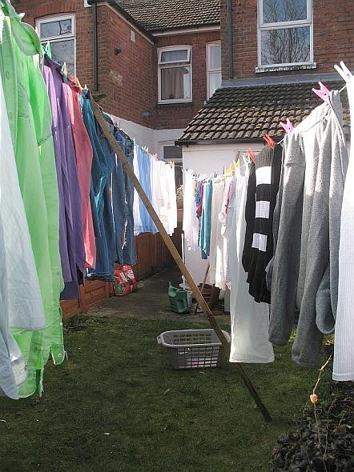
Note on the photos:
- A factory which has been demolished in the last few months. The sound of the scraping shovel came from behind a hoarding which now fences off the site.
- A field near where I walked and heard the children’s and birds’ voices.
- My backyard this morning just after I hung out the clothes.

touching Eternity
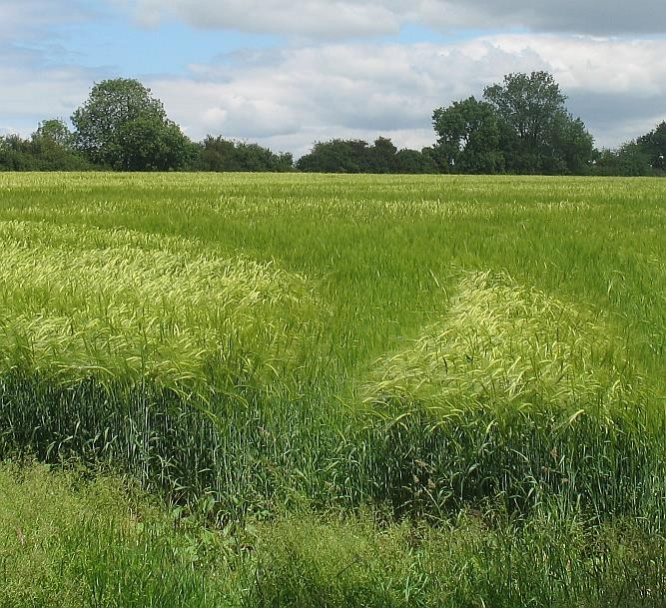
When we speak of God or gods, it’s to express the otherwise inexpressible. This is something that atheists and materialists seem to wilfully misunderstand, when they say that it’s irrational to believe what you cannot see. As you’ll see from various entries in this blog, there are two kinds of immortal I can’t do without when trying to make sense of experience: the Angel and the Muse.
The angel’s principal role is to herald and remind, to help bring about a state of consciousness. In my experience the angel is neither male nor female, and may be imagined in any form or none. It may whisper as a voice, in definite words; or in pure meaning, which cannot be expressed to others without translation into a human language. Sometimes the angel simply shows, with gestures or tableaux, even a little silent play with several actors, which unfolds before your eyes, on the fringes of normal reality. Many have met the anonymous helper who turns up when you are in trouble, such as arriving in the form of a stranger who helps get your broken-down car started again. Many of us get the privilege to “be an angel” for someone else. I maintain that the angel’s role is less to intervene and more to prompt a response in our hearts: to lift us up, and make us understand that this world has mysteries beyond the reach of science and atheism; and show that despite all appearances, this world is our friendly home. I get my knowledge of angels from personal experience, often recounted in this blog. Books merely confirm them as universal.
The Muse is formless yet (for me) vaguely female. She doesn’t waste energy by appearing in person, but waits to be invoked, as we know from ancient literature, such as Homer. Her role is to help give birth to form, not her own but the artist’s idea. She whispers words to the poet, to aid the creation of order and sense from chaotic feelings.
When I go a-wayfaring, it’s not just for mundane purposes of exercise and exploring my neighbourhood. The aim of the dog-walker isn’t just the dog’s (or even the walker’s) health and hygiene. The real purpose is something sublime that stays unsaid, or can’t be said. Only in mental quietness, aided by the Muse’s light prompting, can the inchoate underbelly of existence be wrapped in potent words, and brought to the light of conscious understanding.
“Do you believe in angels, then? Do you believe there is such as a thing as the Muse?”
I answer that I am not talking about belief, only expressing. Action is not in itself a creed. If I talk about unicorns, it doesn’t mean I believe them. What I believe is that you and I can share an understanding.
The other day I walked to Downley, Naphill and Hughenden, a round trip of three hours. For the first hour or so, I was merely present to the scene, absorbed in whatever assailed my sense, from within or without. After a while I began to dictate words in the ever-willing ear of my pocket recorder. When I climb up the Pastures to Downley, this tends to happen, sooner or later. The Muse seems to dwell in those hills, and favours me with whispers when I am ready. I’ll share the latest set with you.
When I hear, for example, a certain birdsong, a repetitive single note plangently celebrating June’s glory, it takes me back down the corridor of years, invoking all the times I’ve ever heard it. Now I’m walking in two worlds at once: this public footpath weaving its way round the backs of houses, and that echoing passageway of time. Between these two worlds, I suspect, is the place to touch Eternity.
And in Eternity’s boundless space, I do things I’ve never done, in a time that’s never been, with memories that don’t fit into my life-story; memories of the Never-Was. And I’m not alone in this. It’s man’s inheritance.
My footsteps traverse a labyrinth of tidy suburban roads, small-scale, leading nowhere, with names like Cherrycroft Gardens, echoing places I’ve lived, like a house called Cherrydown on the Isle of Wight. In my mind’s eye, I’m not seeing that house now, but some place on the furthest shore of consciousness, in a different dimension. Perhaps my whole life is flashing before me in little snapshots, for June birdsongs are still loud in my ear [so loud when I play back the recorder!], and they take me to memories I’d forgotten, in a nonchronological sequence that feels like another life, one I never lived. Then I realize these fleeting memories are not so much scenes from the world, but from my imagination at the time: not the house Cherrydown, but stray images and even angel-encounters from the time I lived there, going back to a still earlier time. Might they be echoes of Eternity?
And now that I’m tuned to the notion of everything I see or hear or smell or think being connected to a memory, there is no stopping me. I look across at a public allotment, where a gardener has left rhubarb and onions unharvested, so that their leaves and stalks have grown huge and unfamiliar, with stylized buds, flowers and seedheads; the onions like decorative turrets of a fairyland castle, the rhubarb with loose bunches of flat seeds resembling those of the dock, Rumex Obtusifolius, for they are related, in the family of Polygonaceae. Just looking at those overgrown vegetables takes me to some fabled court in the kingdom of evolution; a kingdom in which I, too, flourish.
Now I wander on, in this outlying suburb of a village, approaching the woods and meadows of I know not where. There’s a map in my trusty wayfaring bag, but I don’t bother to consult it. My route feels all right. I know it will eventually take me home. In the broader sense, I’m already home, for this is my extended neighbourhood. It’s within my foot-travelling reach, so shouldn’t I get to know it? Literally, my backyard is tiny. But in a wider sense my backyard is all around, my journey-zone (journée means day’s travel). It includes that Victorian prime minister Benjamin Disraeli’s Hughenden Manor, though it’s closed to the public today. I’m going south now, I can tell from the position of the sun. That’s the direction of home. My brother confessed the other day to forgetting that the midday sun hangs in the south; for in New Zealand, it hangs in the north. When in doubt I follow a footpath, for they all go somewhere, unlike the roads built for cars, which often lead to dead ends.
Now I see a white-haired grandfather on the road ahead, pushing a little child on a buggy, amusing himself and possibly the child by letting it run free, down the gentle slope. I see that the grandfather could be me. The child could be me. The seedheads in the allotment, anything could be me. Every person I ever see in the street could be me. But I have to admit that I seldom see this unity, seldom have a need to try. Today’s a holiday from normalcy, while the Muse takes me by the hand.
So I see that everything is there all the time. All it needs is a quiet presence, and some kind of trigger, for Oneness to be manifest. Or it might never happen in this lifetime. But is this what I am doing in my life, beyond mere survival: to seek little openings to that Eternity whence I came?
In the words of the late journalist Robert Ripley, “Believe it or Not!” For as every writer of fiction knows, the important thing is not to believe, but to imagine. Imagine vividly enough, and you have belief. But that’s no reason to go to war with someone who believes (i.e. imagines) differently.
Such is the Muse, dear reader. Such is the messenger angel. And such is
life.

PS
How can you possibly know Eternity? asks the logician. The man in the street knows better. Enter Arthur Stace, famous Sydney wayfarer, introduced here in an entry from an on-line Directory of Australian Writers and Artists.
Arthur Stace was a reformed alcoholic who for 35 years was inspired to write the word ‘Eternity’ in perfect copperplate in chalk on the streets of Sydney. Many people who lived in Sydney between 1932 and 1967, and those who visited, would have seen the word written on footpaths. It was a mystery for years, until 1956 when it was revealed to be the work of Arthur Stace. He wrote ‘Eternity’ over half a million times. Arthur Stace grew up in poverty, and was jailed at the age of 15. After serving in France during the First World War, he returned to the streets of Sydney, partially blind, unemployed and an alcoholic. One day, drawn into the Burton Street Baptist Tabernacle with the promise of a free meal, Arthur Stace encountered something that changed his life, as he described to a journalist from the Daily Telegraph in June 1965, two years before his death:

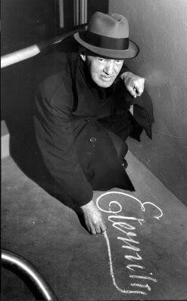
“John Ridley was a powerful preacher and he shouted, ‘I wish I could shout Eternity through the streets of Sydney.’ He repeated himself and kept shouting, ‘Eternity, Eternity,’ and his words were ringing through my brain as I left the church. Suddenly I began crying and I felt a powerful call from the Lord to write ‘Eternity’. I had a piece of chalk in my pocket, and I bent down right there and wrote it. I’ve been writing it at least 50 times a day ever since, and that’s 30 years ago. The funny thing is that before I wrote it I could hardly write my own name. I had no schooling and I couldn’t have spelled ‘Eternity’ for a hundred quid. But it came out smoothly, in a beautiful copperplate script. I couldn’t understand it, and I still can’t. I’ve tried and tried, but ‘Eternity’ is the only word that comes out in copperplate. Eternity gets the message across, makes people stop and think.”
Arthur Stace’s publications include: “Eternity” self-published and republished approx. half a million times over a thirty year period in Sydney.

on high
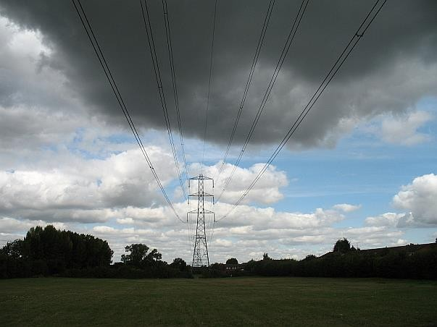
I’m on a section of the “Round Aylesbury Walk”. If you go clockwise, the town is on your right and level countryside is on your left. I talk to myself as I go, into a digital recorder, as follows (edited, of course).
Suppose everything is just as it should be, already? Suppose everything goes on being just right, no matter what? So that no matter what creatures do— mainly man, for other creatures don’t disturb the balance as we do—then Nature as a whole (which includes mankind) bounces back, fixing the consequences as best it may? This is what James Lovelock calls Gaia. Isn’t it a vast freewill machine? Yes! That’s it! So when pain-bringing events arrive, we cannot accuse, saying “This is God’s fault”. It’s just that the boat has been rocked. It just goes on righting itself, as Gaia does. And suppose that all the religions, too, are products of freewill, also trying to fix the fallen state, the loss of Eden’s innocence. I don’t believe that religion is God’s gift to man, a rescue from original sin.* Christianity is just part of the general freewill, nothing more than that. It has no holiness above anything else.
I hear a crackling in the power-lines hanging down over me. The sky has gone black. I wonder if it is man’s electricity responding to God’s electricity, or vice versa. The crackling is faint and almost constant, like hailstones bouncing off a small drum.
So, in this model which appears quite clear to me now, it’s not even for us to identify the problems. It’s for us to disturb as little as possible the workings of Nature, which constantly tries to clean everything up. Technology has become overwrought. But then, reason itself has become overwrought. Can technology and reason save us from technology and reason? I cannot find any cogent reason to answer “Yes”.
Suppose I eliminate from my thought, the phrase “We should ...”? The next thing would be to eliminate the phrase “I should ...”. It doesn’t come easy, because this is my culture, to constantly see problems and the need for me to participate in their solution. Solutions, of course, cause problems of their own. I should help fix those too, and so it goes on. I don’t deny that the word “should” properly belongs in the English language. But I challenge its power over my life. I shall merely follow instinct, which is Nature in action.
I walk freely, because it is part of God’s gift: God’s gift of this body that’s rather awkwardly, yet quite definitely, designed for bipedal locomotion.
And as I speak these words, striding across a meadow under the powerlines, I see shining in the grass at my feet a £1 coin. I stoop to put it in my pocket, thinking, “This is my deserved reward. I can buy something with this.” And as with the four-leaved clover that day with Michael, I ask myself, “Will there be another?” I look for another pound coin, as if there were going to be a trail of them. This too is Nature, human nature.
If only I could convey the manner in which, as I walk, I think these thoughts and feel my feelings. It’s as if I’m leaping up to a ceiling that’s suddenly become reachable, and I touch Heaven. Then again, and now again. And because Heaven doesn’t reach low enough, or I am not tall enough, I can only do it with little leaps. But my dear, my dear dear reader, this is all, or enough. I don’t ask for more. I’m not impatient. Why should I be? To touch Heaven once might be enough in a lifetime. But of course, when we have a pleasure, we want to repeat it. Addictiveness is a human tendency.
Suppose we didn’t ask for the same pleasure again, suppose we didn’t try and make it happen again and again. Would that improve things? No of course not. Because it’s the way we are made. We are programmed to seek pleasure and avoid pain. And why on earth should we try and escape the cycle of that? (Or indeed, if we are some kind of crazy Buddhist, say, why should we try to prevent ourselves from trying to escape that, if that’s what we want to do?)
I arrive at a heavenly cycle path, known as Pebble Way. It’s not exactly as if I want literally to embrace the people I see today. It’s as if I want to escape (in imagination only) from being this particular white man, at this particular mature age, to be one with people of all ages, people who cycle on this path, walk along it, live in houses alongside it, who live in the cottage in my illustration, with its beautiful back garden—and all, who like me, don’t live here, alongside this cycle path.
I feel myself near enough to it, this Heaven. Because there is some sort of realm, maybe 14ft above the ground, maybe wafting over this place, where Heaven is. Then it (the heavenly Pebble Way) merges with the Gemstone Cycle Route as it goes into town. I have no bicycle, but no worries, it’s a footpath too. Signs keep counting down the number of estimated minutes left to reach the town centre, if you are travelling by bicycle. “10 minutes to Town Centre”. Then three minutes later, “5 minutes to Town Centre”. I must have lost my sense of time. Surely I’m not going faster than a bike. Anyhow, nothing would tempt me to get one, whilst I can walk on two feet which don’t have to be chained up against theft. All the same, remembering when I first rode a bicycle—how fast! how free!—my soul goes in sympathy with an imagined cyclist, riding from one of the poorer suburbs to the train which will take him to another town where he is apprenticed to the future he desires. Perhaps that is his vision of Heaven.
I pass the Church of Jesus Christ of the Latter-Day Saints. Reading the name Jesus Christ, my heart lifts a little as if I am one of their number, ready to be there when they go marching in. But mine is a fabricated dream-Jesus, not the historical one whom nobody knows; or a restored version, like a fresco whose original has crumbled, as in Leonardo’s Last Supper. Even though it has never happened to me, I don’t deny that one could have Jesus in one’s heart, and be utterly transformed by that presence.
Others will find the object of their quest, their ideal, in some other form. It’s a peculiar Western cultural thing, from which I am not immune, to confuse the boundaries of sex and religion in the true fairy-story of romantic love. It is orthodox to speak of “the woman of your dreams”. In fact at this minute one walks before me, dressed all in black. Specifically, she reminds me, I don’t know why, of a certain long-ago, never-forgotten dream inspired by the book Alice in Wonderland, itself about a girl dreaming.
We have one word, dream, for two quite different things: the hallucinations of sleep, and the waking fantasies and might-have-beens. So now, as I cross the real-life Bourg Walk Bridge in Aylesbury, I let the cinecamera of imagination keep running, without ever calling “Cut!” from my director’s chair.
I could be the owner of this little house near the railway station, with the crooked chimney and well-tended garden. Or that young black woman. Maybe this yellow and white cat with a wounded tail that sprawls soaking up the warmth on this footbridge.
It’s the long summer holidays, and in August the young find things to do. I might be any of them: this gangling boy, aged about sixteen, waiting for a rendezvous by a privet hedge on the Pebble Way. He and his friend overtake me later, hastening to their destination. I eavesdrop the earnest conversation. One confides all his half-formed ideas to the other, who listens and offers a few sage words in response. I could have been either of them, speaker or listener.
I reach Penn Road, Southcourt, where several houses are empty, fenced off for building works as part of an urban regeneration project. Here is a group of little children in a scruffy front garden, sitting on a lawn bleached by drought. Some have their bicycle helmets still on, their bikes flung down randomly. About seven of them are clustered around a Monopoly board, together with a neglected plate of sandwiches. They too are in Heaven. I could be one of them.
I can’t decide if Heaven consists in this—the world of the senses, including my sore feet—or in the constructed images of my waking dream, hovering a few feet off the ground, with my individual identity blurred and melted into what I perceive. Is it my Heaven to live in a mystical cloud, or to be right here, in the body God gave me? I shan’t choose one way or the other. All I know is, I have touched it. I have touched it in my good times. I have touched it in my worst times. And that’s enough.
———
* Re original sin, I appended the following as a comment, afterwards:
I saw a man later that day, whose black T-shirt had this on the back, in letters four inches high: “John 3:16”. I guessed what verse from St John’s Gospel it was referring to; correctly, as verified later. Here is the verse, in the text of the Authorized Version:
For God so loved the world, that he gave his only begotten Son, that whosoever believeth in him should not perish, but have everlasting life.
A verse which summarises the Christian case, and also exposes its weakness: being an unverifiable sales slogan.

trail to Marlow
I’ve never taken this trail before, this walk to Marlow on the last day of January, on a cloudless frosty day. How often it happens, on my wayfaring, that something triggers a memory, perhaps of a single second in my life, usually in childhood, for it was then that I most frequently encountered something for the first time, and entered openheartedly into that experience. That second expanded then and expands now, almost to infinity. Perhaps it was a colour, something sparkling, something translucent, something which glowed; the slightly blue-tinged green of a field, with its shoots of young wheat. Or a newlyploughed field, where the plough had brought to the surface a large white flint, and I stared at it. You see, there’s a feeling, but I can’t say what it is.
And then I try to communicate in words, and find that more words won’t make it easier. Fewer words are better when the task is to point towards something that can only be felt. It is not my description that will make things clearer to the reader. It can only be the reader’s own journey, which I must not hinder—to an untouched place, an archipelago of imagination.
I’m fully aware, John Myste [fellow-blogger], that I have not responded to your generous comment on the topic of poetry, appended to my last. I shall be lazy and not respond point by point, but merely dedicate this whole post to you, hoping you will forgive. Like you I am utterly beguiled by the magic and possibilities of poetry. Like you I am unimpressed by most poetry. It had an impact in my early years and I still like the same things now as then. Poetry takes us to places we didn’t know before, but its magic is to give us the sense of recognition.
And this is how I would define my god, if I wanted to use the word, which I usually don’t: a Presence, an attentive Presence, there in times of need; the need to give thanks and the need to beg, and the need to surrender one’s life to something higher. To surrender in advance if you will, because death will come willy-nilly, death the force majeure. It forces us to let go of all that we know with our mortal mind. But perhaps there is an immortal mind, always hidden, or perhaps not so hidden. Perhaps the immortal mind takes wing after death, why not? Yet one can dwell contentedly not knowing.
At this point I have just been overtaken by a fellow- wayfarer, on this beautiful footpath. She’s walking faster. She said something as she approached from behind, so that I wouldn’t jump in surprise. What a gracious person! One of those angel-sent strangers who greets and passes on, the human manifestation of an invisible Presence, leaving me to resume this conversation with the world.
I’m at a place on the map called Burroughs Grove Hill. There’s nothing much here, apart from the landscape. I take a bridle-path which wends its way, over hill and down dale, till it reaches Marlow Bottom. It’s undoubtedly ancient, probably prehistoric, but in this moment I feel it as mediæval. I wouldn’t be surprised to encounter a travelling vendor bringing silks, ribbons and lace, to show the high ladies of the castle; a juggler on his way to the Fair; a mountebank; or a jester in cap and bells, clad in motley. Now I see in my mind’s eye a boy of fifteen, driving his pig to market with a stick.
The well-known Ridgeway, a few miles west of here, is reputed to be the oldest road in Britain, dating back to prehistory. Give me this one instead, which has no name! It has been spared the indignity of motor vehicles. They run on parallel roads, ones which go round the hills, not up and down them. It’s too steep here for any but foot-traffic.
Birds are singing joyfully in the hedgerows, as if to herald Spring. I don’t know which path to take. I am near to a copse closely planted with young ash trees, I recognise them from the smooth grey bark and the black buds. There are paths through it, and paths beside it.
A website tells me (I checked later):
There is a buffering strip, Kimber’s Copse (Compartment 3), to the eastern side of the wood to protect this ancient wood from further damage by agriculture practices or development pressure. This is naturally regenerating well with mostly ash and some oak seedlings.
The site has an extensive network of well-used public paths that are clearly appreciated by the local people who walk them. There is strong support from the Marlow Residents’ Association for the management regime in the wood.
Once again, my memory goes back to my time as a five-year-old in Holland, in 1947, though I was never there in this season. Almost all my memories of that time are of wandering alone in the open air, absorbing new experiences. Certainly I went the mile or so to school on my own, and I don’t think I always took the most direct route. It was near Arnhem, not long after the war ended. I didn’t see wreckage of planes, they would have been quickly recycled I supposed, but there were little items scattered in a field: nuts and bolts, tiny fragments of mirror, glinting in the sun.
I was only five, but I can visit it again, with my adult brain looking through the child’s eyes, a kind of Remote Viewing, but in time, not space. This life is glorious.
A metal plaque against a tree is dedicated to the loving memory of “Olga McDonald who loved nature and reading and hated ginger biscuits ... & inspired our interest in all living things ... educated us not just to look, but to have a...” (I tried to photograph it on my mobile phone. It wasn’t too legible but this was the gist.)
Later, coming near to a few houses, there’s a tree hung with catkins, sure sign of wintry regeneration. It’s also hung with several green net bags of peanuts, already pecked clean by the birds.
And I feel that whoever took the trouble to put up that plaque, perhaps remembering a grandmother; whoever hung bird food on trees out in the countryside at some distance from their own house and garden, they did so feeling a Presence.
Now I arrive at human habitations. These footpaths are sacrosanct, slicing their way between the dwellings, narrow now between the high fences of adjacent back-gardens. Over these walls I hear indistinct men’s voices like the droning of bees, women’s voices like the chatter of birds in a tree. The sunshine is bringing out householders and their neighbours, on any excuse to rejoice and look for premature signs of Spring.
I hear children’s voices in the distance, echoing in the woods. I descend a steep urban footpath with a handrail in the middle, to which someone has strapped a child’s wristwatch. I gaze closely at its dial. It’s working, telling perfect time, waiting for its carefree owner to come back looking for it. Who says time and tide wait for no man? Free and easy: reminds me of where I was born, in the nineteen-forties, Bassendean, a suburb of Perth, Australia.
I may be wrong but I think that the moments I go back to, the ones which expand almost into infinity, are those which weren’t used up the first time round. They happened but they weren’t fully lived and savoured. How fortunate to be able to live them again.
By the time I get to Marlow, I’ve walked eight miles. I take the bus back.

pilgrimage
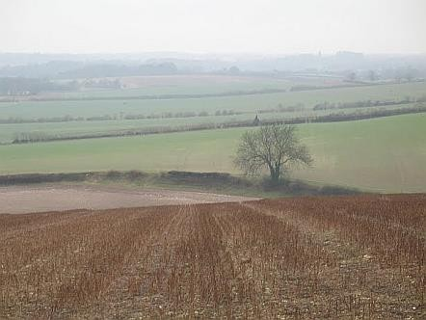
I’m on this path. I don’t know how far I’ve been, I don’t know where I am on the map. I hear planes criss-crossing distantly above the fog. I’m on the crest of a slope, looking out on rows of stubble, which bristle in parallel stripes over the curved surface of the fields. The landscape is wild, hardly a human habitation to be seen, yet deeply scored and shaped by human purpose: for example this footpath, which goes off in straight lines across the piece with a self-important certainty. It cuts across a road hidden in the fold of the valley, then continues true to its original purpose, which no living person may remember, for it ends up in a wilderness which I can’t identify. Sure, there are signposts, but most of them are worn and bleached by time, except those which say “Footpath” or “Bridleway”, which doesn’t help establish where on earth I am.
From a height I see the landscape laid out like a map. I feel a connection with it, as to some unidentified, half-remembered fragment of my own past. All I can see is that everything has its agenda: these blue-green wild-plants spread flat, star-shaped in the meadow between the stubble-stalks, catching droplets of dew, or perhaps this continuing drizzle they call “Scotch mist”, so thin and steady that I’d forgotten about it till this moment. Surely, I too have my agenda, pursuing it diligently like every other force of nature.
Why else am I drawn to cross this landscape and record my thoughts, producing these “Records of a Weather-exposed Skeleton”*? For I’m out in the weather, wondering why I am here, I mean here on earth, not just this moor; exploring my provenance and destiny, not with any focused purpose, just making incidental discoveries. I’ve never plotted my path far ahead. It’s against everything I stand for, to do such violence to the delicate intake of sense and impulse, as to pursue an ambition and force myself to follow the course set by conscious intellect. People certainly do that: they crash through the undergrowth of indolence and self-indulgence by sheer force of will, and seize their due prize, Success. But a mysterious inner part of me, which gently rules, views such an approach with horror.
Amongst the more literary signposts I stumble upon—long may life reveal itself in such a fashion!—is this, from Pilgrim at Tinker Creek, by Annie Dillard:
I am sitting under a sycamore by Tinker Creek. I am really here, alive on the intricate earth under trees. But under me, directly under the weight of my body on the grass, are other creatures, just as real, for whom also this moment, this tree, is “it”.
. . .
Hasidism has a tradition that one of man’s purposes is to assist God in the work of redemption by “hallowing” the things of creation. By a tremendous heave of his spirit, the devout man frees the divine sparks trapped in the mute things of time; he uplifts the forms and moments of creation, bearing them aloft into that rare air and hallowing fire in which all clays must shatter and burst. Keeping the subsoil world under trees in mind, in intelligence, is the least I can do.
———
* There is this from the poet-monk Bashō, patron saint of my blog:
Determined to fall a weather-exposed skeleton I cannot help the sore wind blowing through my heart. After ten autumns in Edo, my mind points back to it
as my native place.
PS I think I’ve worked out where I went, and where the footpath led from there on: to a cemetery and disused pit. Apt enough. We are all on that pilgrimage. Still, something doesn’t seem quite right. Probably my map-reading. Real life never seems the same as what’s written down.

not trying too hard
I left the car at The Fox and Hounds in Christmas Common, and made my way down Hollandridge Lane, which has never been more than a cart-track, but offers glorious vistas on a perfect spring day. Not a farmhouse in sight, not a fellow-wayfarer or dog-walker, not even a sheep till I reached Pishill, and saw some ewes huddling in the shade, under a curved shelter of galvanised iron. But the bluebells were on parade. The wild violets and wood anemones, dandelion, primrose, white deadnettle, yellow archangel, all greeted me as I passed. It was a day to feel whole, to abandon care, to live in the simplicity of your own clothed and booted body, covering the ground like a Stone-Age wayfarer on a mission, untroubled by too much thought. At least that is what I supposed, for it seemed to me that I had been just walking, with no particular train of thought.
But in the seventh mile, twenty minutes from regaining sight of the Fox and Hounds, an odd idea popped into my head, out of the blue: it’s not a good idea to try too hard. The world is overheated with it—literally. Enough striving, ambition, “pursuit of excellence”. Teachers should stop urging their pupils on. In any case, they don’t really do it for the pupils’ sake, but for targets. Everything is driven by targets. Result: everyone is insecure.
Reader, I’m not preaching my new doctrine. I’m just reporting the thought that came to me in the dappled sunshine, walking back up to Christmas Common, back up that Hollandridge Lane. And since I didn’t know where it came from, I tried to give it meaning and context. Suppose we each did what we found came naturally: sometimes lazy, sometimes driven by the joy of doing what we can do, even indulging it to excess. The standard of living would fall. We would no longer be such slaves to productivity and economic growth. We would gain in personal dignity.
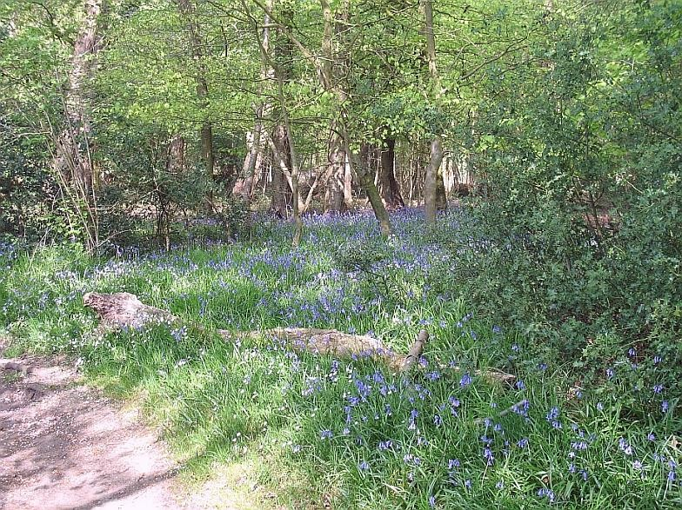
I thought about the various regions of Africa before the European slavetraders, missionaries and colonists arrived. I felt they would have been better off and more in harmony with the rest of Nature. My grandmother was in Kenya in the Fifties. She justified the white man’s appropriation of the black man’s land in terms of her own recollections. She had gone there for her health, to ease her painful arthritis, and liked to sketch scenes in water colours. She said the Africans loved to sit laughing and lazing in the shade of a tree all day, while the white man strained to get the best yield from the land with his plantations of tea and coffee. There was no doubt in her mind which was the good, strenuous, Christian thing to do. And what did the indigenous people think? The young braves among the Kikuyu showed by their deeds how much they appreciated the kindness of the white settlers. They started the Mau-Mau uprising.
So, I found meaning in the thought: “It’s not a good idea to try too hard.” But where did it come from? The blue sky? Then I remembered. I’d been absorbed in Nature, aware that it was much more than the wild flowers, the trees in their new foliage, the calling birds and the bumbling bumble-bees. I knew that creatures struggling for survival eat each other, sometimes even their own young. When the cuckoo hatches in its foster-parents’ nest (in England typically a reed-warbler’s), it heaves the other eggs out, for its appetite matches that of the whole brood. I thought of cuckoos because at the edge of a field I found olive-coloured shells, four of them scattered, the size of pigeon-eggs, and I wondered how they got there. Then I realized I could not put all my vague notions of Nature into one basket; some of them were second-hand anyway, for I am no naturalist. I traced them to their source: Annie Dillard, the Pilgrim at Tinker Creek. Then I had this thought: “I love her writing: but she tries too hard.” It’s none of my business how hard another writer tries, but I thought if she tried less hard, she would be easier to read. Not only that, but she teaches writing too! And in some distant hero-worshipping way, I am her student too, so it matters doubly to me.
I don’t even have to open her book The Writing Life, because the publishers have kindly provided an extract on the dustjacket, from which I take a paragraph to illustrate how hard she tries:
A work in progress quickly becomes feral. It reverts to a wild state overnight. It is barely domesticated, a mustang on which you one day fastened a halter, but which you now can’t catch. It is a lion you cage in your study. As the work grows, it gets harder to control; it is a lion growing in strength. You must visit it every day and reassert your mastery over it. If you skip a day, you are, quite rightly, afraid to open the door to its room. You enter its room with bravura, holding a chair at the thing and shouting, ‘Simba!’
Phew! After copying it out, I feel as though I must go and lie down for a bit. Its magnificence is undeniable; but I prefer understatement. It reinforces an already-established conviction: for me, the blog essay is the highest literary molehill which I dare climb. I do try, but not too hard.
Then, this morning, coincidentally, I read Bryan’s comment on my last. It includes these words.
My number one cardinal rule of writing, which I recently passed on to my daughter, is that good writing should be like good acting. If it’s done right, it shouldn’t even be noticed.
I hope Annie teaches that, too.

Spring be my Muse
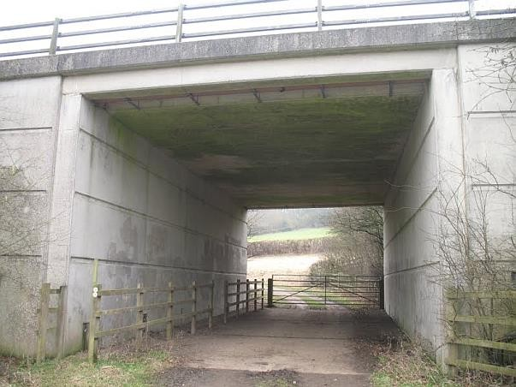
Things are happening in hedgerow and pasture; a spate of fresh wormcasts; larks twittering; occasional sardonic comments by crows. A suddenlysurprised pheasant flaps away from me, going airborne in its panic, plumage bejewelled and voice like a rusty klaxon. Last year’s sunflower-heads, haggard and desiccated, stand witness to the kindness of supplying winter provender for hungry young pheasants, so they can be shot by businessmen in September. That’s farming, part of the pattern of birth and death.
If I were a farmer I’d be surveying the renaissance of these meadows and hedgerows with a prognostic eye. But I’m merely an observer, with no vested interest, no trained eye. I see how the birds, thorn bushes, nettles and wildflowers awaken, each in turn looking to extend its reach. They must sample the wind, temperature and humidity; note the lengthening days and brighter sky. Intelligence distributed in each being, not just brains and instincts, must surely determine when to continue in hibernal mode, when to let the sap or blood quicken for growth or mating. Merely as a wayfarer tramping by in mudcaked boots, I sense all this; using reason only to unravel what I have sensed and convert it to prose.
People refer to “dumb animals”, but the perception is false. In the universe of all living things there is knowledge and wisdom, equally wondrous in every creature. Instinct, acquired skill and reason are equally wonderful. Naturally we extol reason, as one of the defining attributes of the human ape, a gift which matures in each individual. But it’s no more wondrous than the other two.
Instinct is knowledge and wisdom in its stored form, already present in the seed or ovum. No scientific insight can dim its glory. In us, instinctual nature has not been superseded. What the autonomous systems do within our bodies cannot be replicated by reason. These systems keep us alive in almost every varied circumstance, till things become too hostile for our continued singular existence, and we revert to the clay from which we were fashioned. Intellect is not the master of all it surveys. We (our conscious intellectual selves) are wholly dependent on hidden bodily mechanisms. We can’t control them and we cannot replace them with thought.
We acquire many skills in life. The baby takes its first steps, speaks its first words. These are observable milestones, but the skills go on becoming more complex. The underlying mechanisms might be understood and documented in books; but their execution is beyond analysis and cannot be learned from books.
As for reason, we won’t get far without it, “we” meaning I writing and you reading. It differs from the other pervasive forms of intelligence, which make the universe hang together as it does, only in one thing: its spontaneous inventiveness. For example, without the faculty of reason we could not make up new sentences to suit the occasion; nor understand them. Our language would be a set of clichés derived from a phrase-book.
At this moment, in this meadow, I don’t want to talk about reason. It seems too lumbering and insensitive. This hedgerow seems almost inert but it responds to a different timescale, hears a different drummer as you might say. If it were filmed and then speeded up, we’d see how exuberantly it lives, how joyously its component plants and living creatures adapt and coexist, in a great jazz-dance of nature. Yet the excitement can still be felt.
Some of the signs of human industry are a mystery in these rolling meadows; archaeological remains of the very recent past. I saw at the edge of a field, in the shade of an ancient hedgerow, some huge paving stones which seemed to hide something beneath, like the entrance to a cave or sewer, with a neat pile of about 50 bricks on one corner, as if to prevent the stone being lifted. I could not make sense of it.
There was a time when most phenomena could be ascribed to God because no other explanation was available, and this ascription had the advantage of uniting everything known or unknown. You could talk of Divine Providence, as I still do, without any prescribed worship. It’s true that today, there are more explanations, but they don’t diminish Providence: they fill out the rough outlines with more detail, a kind of fractal recursiveness. I’m confident that mysteries will always outrun explanations.
What I see in these fields, cultivated for two thousand years at least, is effort: by man but also his near and distant relations, the fauna and flora. Impulse precedes effort. For the miracle of life there has to be potential energy. Most of it comes from the sun. Then there has to be purpose, at any rate, that’s what I lightly believe. If you say it was randomness I will not burn your books. Potential energy is there but purpose-driven impulse, I think, is what lets off the brakes so that potential energy turns into kinetic. Or to put it another way, Nature doesn’t fool around in mindless interaction for its own sake. Ask James Lovelock; he’s spent his life gathering evidence. Not that nature is perfect. It makes mistakes. We have only to look at ourselves, or (to see them more readily) at one another.
I seem to gain a kind of direct knowledge, tramping these fields: a peripatetic philosophy open even to the illiterate, like a ploughman who walked these fields a few centuries ago, whose entire spoken eloquence derived from the Bible cadences he had heard.
I see that human separateness—from one another and from the rest of Nature—is an illusion; a necessary one, whose potential is built-in and whose actuality is gradually learned in early childhood. I call it the primary illusion, from which others derive along with philosophies and religions. I have no authority to say it’s an illusion, other than personal certainty derived from intuition whilst passing through landscapes, and confirmation from others* who have travelled the same paths, viewed the same reality.

* See for example The Spell of the Sensuous: perception and reality in a more-thanhuman world, by David Abram.

whithersoever
I went on a small journey in preparation for a bigger one. On Monday I fly out to Amsterdam, so this little trip to Loudwater was to change some pounds to euros at a bureau de change. I set off in walking boots, they’re best for my swollen toe-joint. I might have gone on foot via the Valley Path, but when I passed the bus station there was one leaving for Flackwell Heath, so I gladly leapt on. The warm embrace of a bus, its judder and roar, transports me to the Forties and Fifties of my childhood, for in essence diesel buses have not changed. They are a surviving technology like fountain pens and notebooks. I used all three at once, for there I was scribbling away amongst the peaceful chattering of fellow-passengers, whose cadences hadn’t changed either in the last sixty years. On one side were two white-haired ladies; on the other an attentive mother with her bright toddler. I felt ageless.
I could see the driver from where I sat, an alert young man, apparently half-Chinese, with a pleasant countenance. At the next bus stop a young couple with facial piercings got in. She showed her concession pass; he told the driver he’d forgotten to bring his. “But we’re together,” he added, implying they held their eligibility in common. I’m sure this was against the rules but the driver waved him on, putting the principle of pleasantness before profit. He was sure of himself, his skilful control of the vehicle, his responsibility for everyone’s safety. Thus I surprised myself: seeing as it were through a bus-driver’s eyes.
The toddler had been chattering to his mother, pointing things out right and left, but the motion and noise of the bus put him soon in a doze, and he slumped forward, his little head threatening to bump a metal side-rest. Mother stood up, put her hand in the way like a cushion. Then it was time to get off so I pushed the bell for the next stop. The mother followed, toddler on one arm, pushing buggy with the other, so I helped her lift it to the ground. I was ageless but caught myself feeling like a teenager. Flackwell Heath somehow has this effect on me, wiping out the years, as I wrote on my birthday last year*.
Once off the bus, I noted how good my boots felt, ready for a long trek, though it was only a mile to my current destination. It might be a good idea to wear them all the time in Amsterdam. I passed through a housing estate where the lilacs were all out: white, mauve and purple. I saw a couple of birds walking along the gutter, I’m guessing young partridge, but I don’t know what they were really. It was pointless trying to take a photo, birds always flee at the sight of my camera. But soon I was through a gate and into the greenwoods, no forest but a strip perhaps planted to drown the sound of cars on the motorway which cuts through these hills, like two fast rivers, with flotsam whizzing in both directions. I saw these roads with their cargo of cars through gaps in the fresh green leaves, through which they appeared bluish and blurry, their rasping roar offensive to the senses as a giant open sewer would be, with sound in place of stink. I shuddered instinctively at what mankind has done, mankind meaning me of course, despite my detachment in that moment. Some things are necessary though offensive. I suffered this momentary twinge of distaste as anyone unaccustomed would suffer, seeing a production-line of animals on their way to slaughter. The whisperings of those fresh green leaves, the nobility of those tall beeches, were a lullaby to the soul, distancing me so far from ordinary consciousness that I saw the commonplace reality of intercity traffic as a kind of horror.
I looked for the square tunnel under the motorway, built for walkers on the line of a centuries-old footpath, but missed it. Instead I found a magnificent stairway built into the side of the hill from railway sleepers, with a proper handrail, from which I could descend under the motorway where it bridges some local roads. I had to cross one of these: the traffic was busy both ways, but I was in no hurry, looking to right and left, waiting for the moment when I could saunter across at my own pace. I’d never known traffic like this in the Forties and early Fifties. Behind me, though, were some houses in a country style of about 80 years old, above a steep bank, set back behind the road. I imagined their owners keeping large dogs, cooking on wood-fired cast-iron ranges, where they would dry out their boots and wet clothes. I’d never lived that way, but suddenly felt that I could have done, whatever that may mean. For I was in the kind of peaceful state where in moments I could imagine being someone else—that bus-driver, that mother, that toddler; or a house-owner I’d never met, living as I’ve never lived.
While I glanced to the right, still waiting to cross the road, my eye glimpsed a single hair, outside the frame of my glasses, quite blurred. I thus unexpectedly caught sight of me, at least a part of me big enough to carry my DNA, the blueprint of this body. DNA is a special thing. It encapsulates your uniqueness but also your membership of a species. From imagining myself to be someone else, I entered a different dimension, one of agelessness, where time, space and individuality were just constructs. Here was a human being, the thing I call “me”, but my consciousness had escaped it to become an observer, feeling a vast respect for that thing, and its membership of something vaster than itself. The experience itself lasted half a second at most, so I obviously didn’t think all these thoughts at the time. I probably had no time to think anything beyond “That’s my hair”, but I’m trying to convey that which had no words, for it was a very specific feeling. And the reason I’m writing this piece at all is for the sake of that feeling, to preserve it as a kind of reference point in life.
This sense of individuality we normally possess is a practical necessity like that roaring motorway. It’s certainly not an illusion, but all the same it’s a kind of screen or curtain, hiding whatever lies behind. Sometimes, in a special case, we can see through a chink, and try to comprehend something bigger.
I wasn’t awestruck or anything. I crossed the road safely, thanks to that necessary instinct of looking after oneself. Above me was the motorway, a fine piece of civil engineering, a Leviathan in concrete. Then I caught sight of a cheeky graffito, carefully constructed in mosaic tiles. I looked for others, but it was a lone star.
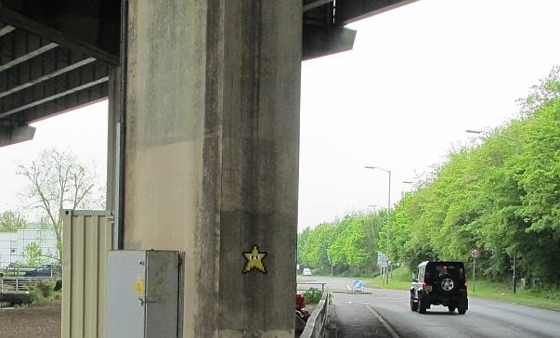
Someone had taken the trouble to design a kind of smiley star, and glue it to a pillar, for some reason, knowing that others would come along, and wonder what it was, and why. As I did myself, enough to mention it in this book.
Sometimes I wonder. . . . Perhaps that’s it. Wondering. That’s all I’ve been doing. That’s what’s been happening. Something makes me wonder, stops me in my tracks. It could be anything . . . anything which fascinates. A young man declaiming like Hamlet, on a stage made of scaffolding on a building site. A snail in all its glory, smiling for a camera that’s run out of film. A blackbird on a chimney-pot, upstaging the Goldberg Variations—but that’s in another book, not yet written. Sudden awe. Thought goes off on its own pilgrimage, unbidden. Emptiness remains. Soul, unquesting, stays. Untaught. Just grateful.
How many roads must a man walk down? It’s all holy ground.

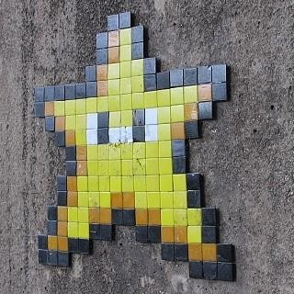

Completed on Easter morning, 2014 in High Wycombe, England

